A Major Project Report on

SMART ALERT DEVICE FOR PREGNANT/DIFFERENTLY ABLED PEOPLE
Submitted in partial fulfilment of the requirement for the award of degree of BACHELOR OF TECHNOLOGY
IN
ELECTRONICS AND COMMUNICATION ENGINEERING

Submitted By

P. JYOTHI SWAROOP BABU | 228R1A04B5
P. BHARGAVI | 228R1A04B6
P. SAI NIKHIL | 228R1A04B7
P. PRANITHA | 228R1A04B8

Under the Guidance of
K. SUBRAMANYA CHARI Assistant Professor
ECE DEPARTMENT


DEPARTMENT OF ELECTRONICS ANDCOMMUNICATION ENGINEERING
UGC AUTONOMOUS
(Approved by AICTE, Affiliated to JNTUH, Accredited by NBA, NAAC) Kandlakoya(v), Medchal, Telangana.
2025-26

CMR ENGINEERING COLLEGE
(Approved by AICTE, Affiliated to JNTUH, Accredited by NBA, NAAC) UGC AUTONOMOUS
Kandlakoya (v), Medchal, Telangana.

Department of Electronics and Communication Engineering


CERTIFICATE
This is to certify that the Major Project work entitled “SMART ALERT DEVICE FOR PREGNANT/DIFFERENTLY ABLED PEOPLE” is being submitted by P.JYOTHI SWAROOP BABU bearing Roll No:228R1A04B5, P.BHARGAVI bearing Roll No:228R1A04B6, P.SAI NIKHIL bearing Roll No:228R1A04B7, P.PRANITHA bearing Roll No:228R1A04B8 in B.TECH IV-II semester, Electronics and Communication Engineering is a record bonafide work carried out by them during the academic year 2025-2026.The results embodied in this report have not been submitted to any other University for the award of any degree.

INTERNAL GUIDE | HEAD OF THE DEPARTMENT
K. SUBRAMANYA CHARI | Dr. SUMAN MISHRA

EXTERNAL EXAMINER

ACKNOWLEDGEMENT

We sincerely thank the management of our college CMR ENGINEERING COLLEGE for providing during our project work.
We derive great pleasure in expressing our sincere gratitude to our principal Dr. A.S. REDDY for his timely suggestions, which helped us to complete the project work successfully.
It is the very auspicious moment we would like to express our gratitude to Dr. SUMAN MISHRA, Head of the Department, ECE for his consistent encouragement during the progress of this project.
We take it as a privilege to thank our project coordinator Dr. T. SATYANARAYANA, Associate professor, Department of ECE for his ideas that led to complete the project work and we also thank his continuous guidance, support and unfailing patience, throughout the course of this work.
We sincerely thank our project internal guide K. SUBRAMANYA CHARI, Assistant professor, Department of ECE for his guidance and encouragement in carrying out this project.

DECLARATION

We hereby declare that the project work entitled “SMART ALERT DEVICE FOR
PREGNANT/DIFFERENTLY ABLED PEOPLE” is the work done by us in campus at CMR ENGINEERING COLLEGE, UGC AUTONOMOUS Kandlakoya during the academic year 2025-2026 and is submitted as Major Project in partial fulfilment of the requirements for the award of degree of BACHELOR OF TECHNOLOGY in ELECTRONICS AND COMMUNICATION ENGINEERING from JAWAHARLAL NEHRU TECHNOLOGICAL UNIVERSITY, HYDERABAD.

P. JYOTHI SWAROOP BABU | 228R1A04B5
P. BHARGAVI | 228R1A04B6
P. SAI NIKHIL | 228R1A04B7
P. PRANITHA | 228R1A04B8

CONTENTS | PAGE NO
LIST OF FIGURES | i
ABSTRACT | ii
CHAPTER 1
INTRODUCTION
1.1 OVERVIEW | 1
1.2 OBJECTIVES & SPECIFICATIONS | 4
1.3 ORGANIZATION | 6
CHAPTER 2
LITERATURE SURVEY
2.1 EXISTING SYSTEM | 9
2.2 PROPOSED METHOD | 12
2.3 INTRODUVTION TO EMBEDDED SYSTEMS | 14
CHAPTER 3
SOFTWARE REQUIREMENT
3.1 ARDUINO IDE | 18
CHAPTER 4
HARDWARE REQUIREMENT
4.1 ARDUINO UNO | 29
CHAPTER 5
BLOCK DIAGRAM & WORKING | 32
CHAPTER 6
RESULT | 62
CHAPTER 7
APPLICATIONS, ADVANTAGES & LIMITATIONS
7.1 APPLICATIONS | 64
7.2 ADVANTAGES | 65
7.3 LIMITATIONS | 66
CHAPTER 8
CONCLUSION & FUTURE SCOPE
8.1 CONCLUSION | 67
8.2 FUTURE SCOPE | 68
REFERENCES | 69

LIST OF FIGURES:

FIG NO | NAME OF THE FIGURE | PAGE NO
Fig 1.1 | Blocks of hardware embedded system | 15
Fig 3.1.1 | USB cable (A plug to B plug) | 18
Fig 3.1.2 | USB cable (A to Mini-B) | 19
Fig 3.1.3 | Arduino IDE Download page | 20
Fig 3.1.4 | Arduino IDE launch | 21
Fig 3.1.5 | creating new Project | 22
Fig 3.1.6 | Selecting board in arduino | 23
Fig 3.1.7 | Selecting serial port | 24
Fig 3.1.8 | Uploading program to board | 25
Fig 3.1.9 | Program Structure | 26
Fig 4.1 | Arduino uno | 30
Fig 5.1.1 | Block diagram of smart alert device for pregnant ladies | 32
Fig 5.1.2 | Power supply | 33
Fig 5.3 | NodeMCU | 38
Fig 5.4 | Temperature Sensor | 40
Fig 5.5 | Heart rate Sensor | 42
Fig 5.6 | MEMS sensor | 45
Fig 5.7 | LCD Display | 47
Fig 5.8 | Buzzer module | 50
Fig 5.9 | Internet Of Things | 53
Fig 5.9.2 | Fundamentals of IOT | 57
Fig 5.9.3 | IOT Layered Architecture | 61

ABSTRACT
Pregnancy requires continuous monitoring of vital health parameters to ensure the safety of both the mother and fetus, especially in rural areas where access to healthcare facilities is limited. This paper presents a Smart Alert Device for Pregnant Ladies, designed to provide real-time health monitoring and immediate alert mechanisms using Internet of Things (IoT) technology. The proposed system integrates sensors such as a temperature sensor, heart rate sensor, and MEMS sensor to continuously track essential physiological parameters. An Arduino microcontroller is used to collect and process sensor data, which is then displayed on an LCD for real-time monitoring.
In case of abnormal conditions, such as irregular heart rate or elevated temperature, a buzzer is activated to provide instant alerts to the user. Additionally, a NodeMCU module enables wireless communication by transmitting the collected data to a remote server, allowing healthcare professionals to monitor the patient’s condition from any location. The system is compact, cost-effective, and easy to use, making it suitable for home-based and rural healthcare applications. Compared to existing systems, the proposed device focuses on real-time alert generation and remote monitoring, thereby reducing health risks and enabling timely medical intervention. Future enhancements may include the integration of machine learning techniques for predictive analysis and the inclusion of additional sensors for improved accuracy and comprehensive monitoring.
Keyword: Smart Alert Device, Pregnant Women Monitoring, Internet of Things (IoT), Health Monitoring System, Heart Rate Sensor, Temperature Sensor, MEMS Sensor, Arduino, NodeMCU, Remote Patient Monitoring, Real-Time Alert System, Maternal Healthcare, Wearable Health Devices
CHAPTER 1
INTRODUCTION
Pregnancy is a critical phase in a woman’s life that requires continuous monitoring of various physiological parameters to ensure the safety of both the mother and the fetus[1]. Regular health check-ups help in identifying potential complications such as gestational hypertension, abnormal heart rate, fever, and other health risks at an early stage. However, in many rural and remote areas, access to well-equipped healthcare facilities is limited, and frequent hospital visits are often difficult due to distance, cost, and lack of awareness[2]. These challenges increase the risk of maternal and fetal complications, making it essential to develop efficient and accessible healthcare monitoring solutions.
With the advancement of technology, the Internet of Things (IoT) has emerged as a powerful tool in the healthcare domain, enabling real-time monitoring and remote access to patient data[3]. IoT-based systems utilize sensors and communication modules to collect, process, and transmit physiological data to healthcare professionals for analysis. Several existing systems have been developed to monitor vital parameters such as heart rate, temperature, blood pressure, and oxygen levels. However, many of these systems are either complex, expensive, non-portable, or lack real-time alert mechanisms, making them less suitable for continuous monitoring in rural environments[4].
To address these limitations, this paper proposes a Smart Alert Device for Pregnant Ladies, which focuses on real-time monitoring and immediate alert generation. The proposed system integrates sensors such as temperature sensor, heart rate sensor, and MEMS sensor to continuously collect important health data. An Arduino microcontroller is used as the central processing unit to process the sensor inputs and compare them with predefined threshold values. The system provides real-time feedback through an LCD display and activates a buzzer in case of abnormal conditions, ensuring quick attention and response.
Furthermore, the system incorporates a NodeMCU module to enable wireless communication, allowing the collected data to be transmitted to a remote server for monitoring by doctors or caregivers[5]. This feature reduces the need for frequent hospital visits and ensures timely medical intervention. The proposed device is designed to be compact, cost-effective, and user-friendly, making it suitable for both home-based and rural healthcare applications.
Overall, the proposed system aims to improve maternal healthcare by combining IoT technology with real-time alert mechanisms, thereby enhancing early detection of health issues and reducing potential risks during pregnancy.
1.1 OVERVIEW
The Smart Alert Device for Pregnant Ladies is an advanced healthcare system designed to provide continuous monitoring of the health condition of pregnant women. Pregnancy is a sensitive stage that requires regular medical supervision to avoid complications such as high blood pressure, abnormal heart rate, and fetal distress [6]. Continuous monitoring helps in identifying these issues at an early stage and ensures better care for both mother and baby.
Traditional healthcare methods mainly depend on periodic hospital visits and manual check-ups, which do not provide real-time information about the patient’s health condition [7]. This limitation becomes more serious in rural and remote areas where medical facilities are not easily available. Hence, there is a need for a system that can continuously monitor health parameters and provide instant alerts during emergencies.
To overcome these challenges, the proposed system uses Internet of Things (IoT) technology along with wearable sensors to monitor vital parameters such as heart rate, body temperature, blood pressure, and fetal movement [8]. The collected data is sent to a microcontroller, where it is processed and displayed on an LCD screen for local monitoring [9].
The system is also connected to a cloud platform, which allows doctors and caregivers to access patient data remotely and monitor health conditions from anywhere [10]. In case of abnormal readings, the system activates a buzzer and sends alerts to the concerned persons, ensuring immediate medical attention [11].
This device is especially useful for high-risk pregnancies and for women living in areas with limited healthcare access. It reduces the need for frequent hospital visits and helps in early detection of complications, thereby improving maternal and fetal safety [12]. The integration of IoT in healthcare also reduces workload on hospitals and enhances the overall efficiency of medical services [13].
In conclusion, the Smart Alert Device provides a reliable and cost-effective solution for continuous health monitoring during pregnancy. It ensures timely alerts, remote monitoring, and improved healthcare support, ultimately contributing to better maternal care and reduced health risks [14].
In addition to basic monitoring, the system is designed to be user-friendly, compact, and easy to operate, making it suitable for continuous use at home without the need for technical knowledge. The integration of components such as Node MCU and Arduino enables efficient data processing and wireless communication, ensuring reliable performance of the system. The inclusion of sensors like heart rate, temperature, and MEMS helps in tracking both physiological and movement-related parameters, providing a complete health monitoring solution [15].
Moreover, the system supports real-time decision-making by providing instant alerts through buzzer indications and remote notifications, which helps caregivers respond quickly during critical situations. This not only improves patient safety but also builds confidence among users by ensuring constant supervision. The overall design focuses on affordability and accessibility, making it suitable for widespread use, especially in developing regions where advanced medical facilities may not be easily available.
In addition, the implementation of such smart healthcare devices promotes awareness about maternal health and encourages timely medical consultation. It also supports caregivers and family members in actively participating in the monitoring process, thereby improving overall care and support for the patient. Thus, the smart alert device not only serves as a monitoring system but also acts as a preventive healthcare solution that enhances safety and reduces potential risks during pregnancy.
1.2 OBJECTIVES & SPECIFICATIONS
The main objective of the Smart Alert Device for Pregnant Ladies is to provide continuous monitoring of important health parameters to ensure the safety of both mother and baby [16]. The system aims to detect abnormal conditions at an early stage and provide timely alerts to prevent serious complications during pregnancy.
Another objective is to develop a real-time health monitoring system using sensors such as heart rate, temperature, and MEMS to track both physiological and movement-related parameters [17]. This helps in understanding the overall health condition of the patient continuously without the need for frequent hospital visits.
The project also focuses on integrating Internet of Things (IoT) technology using Node MCU to enable remote monitoring by doctors and caregivers from any location [18]. This improves accessibility to healthcare services, especially in rural areas.
Additionally, the system aims to provide an immediate alert mechanism using a buzzer and notifications whenever abnormal readings are detected, ensuring quick medical response [19]. The overall objective is to design a cost-effective, user-friendly, and reliable system that enhances maternal healthcare and reduces risks during pregnancy [20].
The Smart Alert Device is designed using a combination of hardware and software components to achieve efficient performance. The system uses an Arduino microcontroller for processing sensor data and controlling all operations of the device [16].
A NodeMCU module is used for wireless communication and IoT-based data transmission, enabling real-time monitoring through cloud platforms [17]. The heart rate sensor is used to measure the pulse rate of the pregnant woman, while the temperature sensor monitors body temperature continuously [18].
The MEMS sensor is included to detect movement and body position, which is useful in identifying abnormal conditions such as falls or unusual activity [19]. An LCD display is used to show real-time values of all monitored parameters, making it easy for users to understand their health status [20].
The system also includes a buzzer for alert generation when any parameter exceeds the normal threshold limits. A regulated power supply is used to ensure stable operation of all components. The entire system is designed to be compact, energy-efficient, and suitable for continuous usage in real-time healthcare applications [21].
Another important objective of this project is to ensure continuous and accurate data collection from multiple sensors so that the health condition of the pregnant woman can be monitored without interruption [22]. The system is designed to reduce human error in manual monitoring and provide precise readings for better diagnosis.
The project also aims to improve emergency response by enabling automatic alert generation whenever abnormal conditions are detected. This reduces delay in providing medical assistance and increases the chances of preventing serious health risks [23].
In addition, the system focuses on portability and ease of use, allowing pregnant women to use the device comfortably in their daily routine without any difficulty [24]. The objective is to make the system suitable for both home-based and hospital-based monitoring.
Finally, the project aims to create awareness about the importance of continuous health monitoring during pregnancy and to promote the use of smart healthcare technologies for better maternal care [25].
The system is designed to operate in real-time, where sensor data is continuously collected, processed, and updated on the display as well as transmitted to remote devices without delay [22]. This ensures that users and healthcare providers always have access to the latest health information.
The Arduino microcontroller acts as the central unit, coordinating all components and ensuring smooth interaction between sensors, display, and communication modules [23]. The Node MCU provides efficient internet connectivity, supporting fast and reliable data transmission to cloud platforms.
The device is designed with low power consumption so that it can be used for longer durations without frequent charging or power interruptions [24]. This makes it suitable for continuous monitoring applications.
The hardware components are selected in such a way that the system remains compact, lightweight, and easy to handle. The overall design ensures durability, reliability, and accuracy in measuring health parameters under different conditions [25].
1.3 ORGANIZATION
The report is organized in a structured manner to clearly explain the design and implementation of the Smart Alert Device for Pregnant Ladies. It begins with an introduction to the concept of maternal health monitoring and the importance of using advanced technologies for continuous observation during pregnancy [26].
It then explains the limitations of traditional healthcare systems and highlights the need for a real-time monitoring solution that can provide accurate and timely health information [27]. The report further describes the proposed system, including the integration of components such as Arduino, NodeMCU, sensors, LCD, and buzzer to achieve efficient monitoring and alert generation [28].
Detailed information about the hardware components and their working principles is provided to give a clear understanding of how each part contributes to the overall system functionality [29]. The software aspects, including programming and IoT-based communication, are also explained to show how data is processed and transmitted for remote monitoring [30].
The performance of the system is discussed based on the results obtained during implementation, demonstrating the effectiveness of the device in real-time monitoring and alert generation [31]. Finally, the report concludes with the advantages of the system and its potential improvements, emphasizing its importance in enhancing maternal healthcare and ensuring safety during pregnancy [32].
In addition, the report provides a clear explanation of how real-time data is collected from different sensors and processed using microcontrollers to ensure accurate monitoring of health parameters. It also describes how wireless communication is established through IoT technology, allowing continuous data transfer between the device and remote users [32]. The overall system design is explained in a way that highlights the coordination between hardware and software components for efficient operation.
Furthermore, the report emphasizes the reliability and practicality of the system by explaining its ability to function under different conditions and provide consistent performance. It also discusses how the device can be easily used by individuals without technical knowledge, making it suitable for everyday use in home environments [32]. The importance of alert mechanisms and quick response during emergency situations is also clearly presented.
Finally, the report focuses on the significance of implementing smart healthcare solutions in modern society. It highlights how such systems can improve the quality of healthcare services, reduce dependency on frequent hospital visits, and support continuous monitoring. The overall organization ensures that the reader can easily understand the complete workflow of the system from data collection to alert generation and remote monitoring.
The report is further structured to maintain clarity and logical flow so that each part of the system can be easily understood. It explains the overall design in a step-by-step manner, starting from the basic concept and moving towards detailed implementation. The arrangement of content helps the reader to clearly follow how the idea is developed into a working model.
It also includes detailed explanations of how different components interact with each other to achieve the desired output. The coordination between sensors, microcontrollers, and communication modules is described clearly to show how the system performs continuous monitoring. This helps in understanding the complete workflow of the device in a simple and effective way.
The report also focuses on practical aspects such as ease of installation, user convenience, and system reliability. It highlights how the device can be used in real-life situations without requiring complex setup or technical knowledge. The simplicity of design makes it suitable for regular use by pregnant women and caregivers.
Additionally, the organization of the report ensures that all important aspects such as system design, implementation, and performance are covered in a balanced manner. It presents the information in a neat and understandable format, making it easier for readers to grasp both technical and practical details.
Overall, the report is designed to provide a complete understanding of the smart alert device, from its basic concept to its real-time application, ensuring that the reader gains a clear idea about the functionality and usefulness of the system.
The report also ensures a smooth transition between different sections so that the reader can easily connect one concept with another without confusion. It maintains a proper sequence of information, which helps in understanding how the system evolves from design to implementation. Special attention is given to presenting the content in a neat and organized manner, making it easier for evaluation and review. The structured format also helps in highlighting the key features and advantages of the system effectively. Overall, the organization of the report supports better readability, clear presentation, and a complete understanding of the smart alert device and its real-time applications.
Additionally, the report emphasizes clarity and simplicity in presenting technical concepts, ensuring that even readers with basic knowledge can understand the system without difficulty. Proper diagrams, explanations, and logical flow are used to enhance comprehension and avoid ambiguity. The documentation also reflects the practical significance of the project by connecting theoretical aspects with real-world applications. This approach not only improves the quality of the report but also demonstrates the effectiveness and reliability of the smart alert device in providing timely health monitoring and assistance.

CHAPTER 2
LITERATURE SURVEY

2.1 EXISTING SYSTEM
The existing healthcare monitoring systems for pregnant women mainly depend on regular hospital visits and manual check-ups to assess the health condition of both mother and fetus. These systems involve periodic measurement of vital parameters such as heart rate, blood pressure, and body temperature, which may not provide continuous monitoring of the patient’s condition [33].
In many cases, pregnant women are required to visit healthcare centers frequently for routine check-ups, which can be time-consuming and difficult, especially for those living in rural or remote areas [34]. The lack of continuous monitoring increases the risk of missing early signs of complications, which may lead to serious health issues if not detected on time.
Some existing systems use basic electronic devices and wearable sensors to monitor health parameters. However, these systems often lack proper integration with advanced communication technologies, limiting their ability to provide real-time data access to doctors and caregivers [35]. As a result, immediate medical assistance cannot always be ensured during emergency situations.
Additionally, traditional monitoring systems do not provide effective alert mechanisms. In many cases, the data is recorded but not actively analyzed to generate warnings when abnormal conditions occur [36]. This reduces the efficiency of the system in preventing critical health risks during pregnancy.
Another limitation of existing systems is their dependency on manual observation and lack of automation. Healthcare professionals must interpret the data and take necessary actions, which may cause delays in response time [37]. Moreover, these systems may not be user-friendly or suitable for continuous home-based monitoring.
Therefore, the existing systems are not sufficient to provide continuous, real-time, and automated health monitoring for pregnant women. This highlights the need for an improved system that can overcome these limitations by using modern technologies such as IoT, sensors, and automated alert mechanisms [38].
In addition to these limitations, many existing systems are not designed to handle multiple parameters simultaneously in an efficient manner. Monitoring different health conditions using separate devices increases complexity and makes it difficult for patients to manage the system effectively [39]. This lack of integration reduces the overall efficiency and usability of the monitoring process.
Another major issue with traditional systems is the absence of continuous data storage and analysis. The collected data is often not stored in a structured format, making it difficult for doctors to track the patient’s health history and identify patterns or long-term changes [40]. This limits the ability to provide accurate diagnosis and preventive care.
Existing systems also face challenges in terms of reliability and accuracy, especially when used for long-duration monitoring. Sensor errors, lack of calibration, and environmental factors can affect the accuracy of readings, leading to incorrect health assessments [41]. This can create confusion and reduce trust in the system.
Furthermore, many systems do not support remote monitoring, which means that doctors cannot access patient data unless the patient visits the hospital. This reduces the effectiveness of healthcare services, particularly in emergency situations where immediate attention is required [42].
The cost and complexity of some advanced monitoring systems also make them less accessible to common users. Expensive equipment and complicated setup procedures limit their usage, especially in developing regions where affordable healthcare solutions are needed [43].
Due to these drawbacks, existing systems fail to provide a complete, reliable, and user-friendly solution for maternal health monitoring. This creates a strong need for a smart, automated, and cost-effective system that can provide continuous monitoring, real-time alerts, and remote accessibility for better healthcare support [44].
Another drawback of existing systems is the lack of personalization according to the patient’s condition. Most traditional monitoring devices follow a general approach and do not adapt to individual health requirements, which may lead to ineffective monitoring in high-risk pregnancies. This reduces the ability to provide specialized care based on the specific needs of each patient [45].
In many existing setups, there is also a delay in data communication and response. Since the monitoring is not fully automated, any abnormal condition must first be identified manually and then reported to a doctor, which consumes valuable time during emergencies. This delay can increase the risk of complications and affect the safety of both mother and baby [46].
The maintenance and calibration of devices used in traditional systems also pose a challenge. Regular checking and manual adjustments are required to ensure accurate readings, which may not always be performed properly. This can result in inconsistent performance and unreliable monitoring outcomes [47].
Moreover, existing systems do not provide proper data visualization or user-friendly interfaces. The collected data is often difficult to understand for non-technical users, making it harder for patients and caregivers to interpret health conditions effectively [48]. This limits the practical usability of the system in home environments.
Another limitation is the dependency on wired connections in some systems, which restricts the mobility of the patient. Pregnant women may find it uncomfortable to use such systems continuously, reducing their willingness to adopt these technologies [49].
Overall, these limitations highlight the inefficiency of existing healthcare monitoring systems in providing continuous, real-time, and user-friendly solutions. There is a clear need for a smart system that can overcome these issues by offering automation, remote monitoring, accurate data analysis, and immediate alert mechanisms [50].

2.2 PROPOSED SYSTEM
The proposed system is a Smart Alert Device designed to provide continuous and real-time monitoring of health parameters for pregnant women. This system aims to overcome the limitations of existing methods by using advanced technologies such as IoT, sensors, and automated alert mechanisms. It ensures better safety by detecting abnormal conditions at an early stage and providing immediate alerts.
The system is built using a combination of hardware components including Arduino, NodeMCU, heart rate sensor, temperature sensor, MEMS sensor, LCD display, buzzer, and power supply. The heart rate sensor is used to measure the pulse rate, while the temperature sensor monitors the body temperature continuously. The MEMS sensor helps in detecting movement and body position, which is useful in identifying abnormal activities such as sudden falls or unusual movements.
The Arduino acts as the main controller, collecting data from all sensors and processing it efficiently. The processed data is displayed on the LCD screen for real-time monitoring by the user . At the same time, the NodeMCU module is used to transmit the data to a cloud platform, enabling remote monitoring by doctors and caregivers from any location.
An important feature of the proposed system is the alert mechanism. When any parameter exceeds the normal threshold values, the system automatically activates a buzzer and sends notifications to the concerned persons. This ensures immediate medical attention and reduces the risk of complications during pregnancy.
The system is designed to be compact, cost-effective, and easy to use, making it suitable for both home and hospital environments. It reduces the need for frequent hospital visits and provides continuous monitoring, improving the overall healthcare support for pregnant women.
In addition, the integration of IoT technology allows real-time data storage and analysis, which helps doctors in understanding the patient’s health condition over time. This improves diagnosis and supports better decision-making for treatment.
Overall, the proposed system provides a reliable and efficient solution for maternal health monitoring by combining sensor technology, microcontrollers, and wireless communication. It enhances safety, ensures timely alerts, and contributes to improved healthcare outcomes for pregnant women.
The proposed system is designed to operate continuously, ensuring that all health parameters are monitored without interruption. The sensors are placed in appropriate positions to accurately capture physiological data from the user. This continuous monitoring helps in identifying even small variations in health conditions, which can be useful for early diagnosis and prevention of complications.
The integration of Arduino and NodeMCU provides an efficient combination of data processing and wireless communication. Arduino handles the real-time data collection and processing from multiple sensors, while NodeMCU ensures seamless transmission of data to cloud platforms. This division of tasks improves system performance and reliability.
The system also supports real-time visualization of data through the LCD display, allowing users to easily observe their current health status. This feature helps in increasing awareness and enables users to take precautionary measures when necessary. Additionally, the stored data can be accessed later for analysis, helping doctors to understand trends and changes in health conditions over time.
Another important feature of the proposed system is automation. The system automatically compares sensor readings with predefined threshold values and generates alerts without any manual intervention. This reduces dependency on continuous human supervision and ensures faster response during critical situations.
The use of MEMS sensor enhances the system by adding motion detection capability. It can detect sudden movements, posture changes, or falls, which may indicate discomfort or emergency conditions. This makes the system more comprehensive compared to traditional monitoring devices.
The device is designed to be portable and user-friendly, allowing pregnant women to use it comfortably in their daily life. The compact design and simple interface make it easy to operate without requiring technical knowledge. This increases the usability of the system for a wider range of users.
Furthermore, the system ensures secure and reliable data transmission through IoT technology. The use of cloud platforms allows safe storage of patient data, which can be accessed only by authorized users. This helps in maintaining data privacy and improving trust in the system [50].
The proposed system can also be extended in the future by adding more sensors and features such as GPS tracking, mobile application support, and advanced data analytics. These enhancements can further improve the functionality and effectiveness of the system in providing smart healthcare solutions.
2.3 INTRODUCTION TO EMBEDDED SYSTEMS
An embedded system is a combination of hardware and software designed to perform a specific task within a larger system[51]. Unlike general-purpose computers, embedded systems are dedicated to particular functions and are optimized for efficiency, reliability, and real-time performance. These systems are widely used in various applications such as healthcare, automobiles, consumer electronics, and industrial automation [52].
Embedded systems consist of key components such as a microcontroller or microprocessor, memory, input/output interfaces, and software programs. The microcontroller acts as the brain of the system, controlling all operations and processing input data to generate appropriate outputs. These systems are designed to operate continuously and respond quickly to real-time inputs, making them highly suitable for monitoring and control applications.
In healthcare applications, embedded systems play an important role in monitoring vital parameters and providing accurate and timely information. Devices such as heart rate monitors, temperature sensors, and alert systems are examples of embedded systems that help in improving patient care and safety. Their ability to work in real-time and provide continuous monitoring makes them highly useful in critical applications [53].
One of the main advantages of embedded systems is their compact size and low power consumption. These systems are designed to perform specific tasks efficiently without consuming excessive resources. This makes them ideal for portable and wearable devices, especially in healthcare monitoring systems where continuous operation is required.
Embedded systems also offer high reliability and stability, as they are designed for dedicated operations. They can function for long durations without failure, which is essential for applications like health monitoring where continuous performance is required. In addition, they can be easily integrated with sensors and communication modules to enhance their functionality.
With the advancement of technology, embedded systems are now integrated with Internet of Things (IoT), enabling remote monitoring and data sharing. This integration allows users and healthcare providers to access real-time data from anywhere, improving decision-making and response time. Embedded systems combined with IoT are playing a major role in developing smart healthcare solutions [54].
In conclusion, embedded systems are an essential part of modern technology, providing efficient, reliable, and real-time solutions for various applications. Their use in healthcare monitoring systems, especially for pregnant women, helps in continuous observation, early detection of problems, and timely medical assistance, thereby improving overall safety and care.
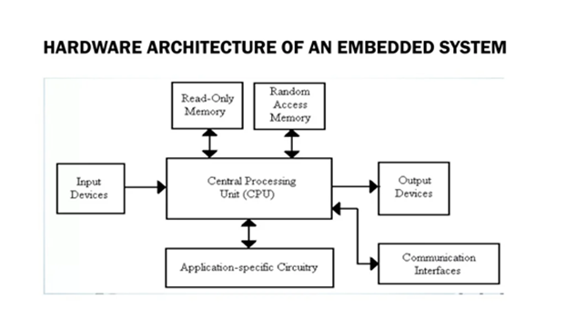

Fig 2.1 Blocks of hardware embedded system
Source : https://image7.slideserve.com/12635392/hardware-architecture-of-an-embedded-system-l.jpg
Now, let us see the details of the various building blocks of the hardware of an embedded system. As shown in Fig. the building blocks are:
- Central Processing Unit (CPU)
- Memory (Read-only Memory and Random Access Memory)
- Input Devices
- Output devices
- Communication interfaces
Central Processing Unit (CPU):
The Central Processing Unit (processor, in short) can be any of the following: microcontroller, microprocessor or Digital Signal Processor (DSP). A micro-controller is a low-cost processor. Its main attraction is that on the chip itself, there will be many other components such as memory, serial communication interface, analog -to digital converter etc. So, for small applications, a micro-controller is the best choice as the number of external components required will be very less. On the other hand, microprocessors are more powerful, but you need to use many external components with them. D5P is used mainly for applications in which signal processing is involved such as audio and video processing.
Memory:
The memory is categorized as Random Access 11emory (RAM) and Read Only Memory (ROM). The contents of the RAM will be erased if power is switched off to the chip, whereas ROM retains the contents even if the power is switched off. So, the firmware is stored in the ROM. When power is switched on, the processor reads the ROM; the program is program is executed.
Input devices:
Unlike the desktops, the input devices to an embedded system have very limited capability. There will be no keyboard or a mouse, and hence interacting with the embedded system is no easy task. Many embedded systems will have a small keypad-you press one key to give a specific command. A keypad may be used to input only the digits. Many embedded systems used in process control do not have any input device foruser interaction; they take inputs fromsensors or transducers 1’fnd produce electrical signals that are in turn fed to other systems.
Output devices:
The output devices of the embedded systems also have very limited capability. Some embedded systems will have a few Light Emitting Diodes (LEDs) to indicate the health status of the system modules, or for visual indication of alarms. A small Liquid Crystal Display (LCD) may also be used to display some important parameters.
Communication interfaces:
The embedded systems may need to, interact with other embedded systems at they may have to transmit data to a desktop. To facilitate this, the embedded systems are provided with one or a few communication interfaces such as RS232, RS422, RS485, Universal Serial Bus (USB), IEEE 1394, Ethernet etc.
Power Supply :
The power supply is an essential part of any embedded system as it provides the required electrical energy for the proper functioning of all components. It converts the available input power into a suitable regulated voltage required by the processor, sensors, and other modules. A stable and uninterrupted power supply ensures reliable system performance and prevents damage due to voltage fluctuations. In many embedded systems, voltage regulators and filtering circuits are used to maintain a constant output. Efficient power management also helps in reducing power consumption, which is especially important for portable and battery-operated devices.

CHAPTER 3
SOFTWARE REQUIREMENTS
3.1 ARDUINO IDE
The Arduino Integrated Development Environment (IDE) is an open-source software used for writing, compiling, and uploading code to Arduino boards. It provides a simple and user-friendly interface, making it easy for beginners as well as professionals to develop embedded system applications. The Arduino IDE supports programming in C and C++ languages with simplified functions and libraries [55].
ARDUINO – INSTALLATION
After learning about the main parts of the Arduino UNO board, we are ready to learn how to set up the Arduino IDE. Once we learn this, we will be ready to upload our program on the Arduino board.
In this section, we will learn in easy steps, how to set up the Arduino IDE on our computer and prepare the board to receive the program via USB cable.
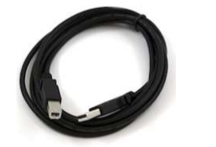
Step 1: First you must have your Arduino board (you can choose your favorite board) and a USB cable. In case you use Arduino UNO, Arduino Duemilanove, Nano, Arduino Mega 2560, or Diecimila, you will need a standard USB cable (A plug to B plug), the kind you would connect to a USB printer as shown in the following image.

Fig 3.1.1: USB cable (A plug to B plug)
Source : https://www.researchgate.net/figure/USB-Cable-A-plug-to-B-plug_fig1_382219996
In case you use Arduino Nano, you will need an A to Mini-B cable instead as shown in the following image
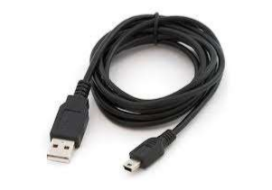

Fig 3.1.2 : USB cable (A to Mini-B)
Source: https://tse4.mm.bing.net/th/id/OIP.S8OY36iIZBdxa2L_mpFvEgHaHa?rs=1&pid=ImgDetMain&o=7&rm=3
Step 2: Download Arduino IDE Software.
You can get different versions of Arduino IDE from the Download page on the Arduino Official website. You must select your software, which is compatible with your operating system (Windows, IOS, or Linux). After your file download is complete, unzip the file.
The Arduino IDE provides a simple and user-friendly interface for writing and uploading programs to the Arduino board. It supports various programming functions and libraries, making it easier to develop and test the project efficiently. This software plays an important role in controlling and managing the overall operation of the system.

Fig 3.1.3: Arduino IDE Download page
Step 3: Power up your board.
The Arduino Uno, Mega, Duemilanove and Arduino Nano automatically draw power from either, the USB connection to the computer or an external power supply. If you are using an Arduino Diecimila, you have to make sure that the board is configured to draw power from the USB connection. The power source is selected with a jumper, a small piece of plastic that fits onto two of the three pins between the USB and power jacks. Check that it is on the two pins closest to the USB port.
Connect the Arduino board to your computer using the USB cable. The green power LED (labeled PWR) should glow.
Step 4: Launch Arduino IDE.
After your Arduino IDE software is downloaded, you need to unzip the folder. Inside the folder, you can find the application icon with an infinity label (application.exe). Doubleclick the icon to start the IDE

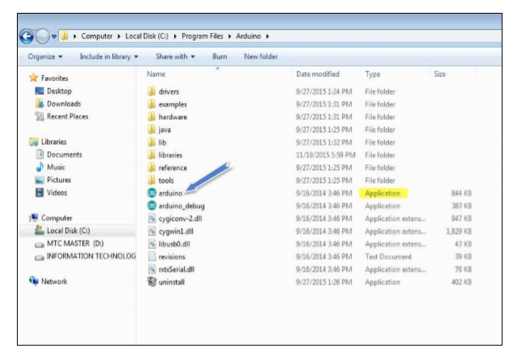
Fig 3.1.4 : Arduino IDE launch
Step 5: Open your first project.
Once the software starts, you have two options:
• Create a new project.
• Open an existing project example.
To create a new project, select File --> New

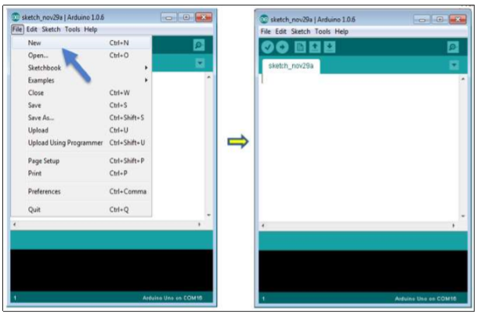
Fig 3.1.5: Creating new Project
To open an existing project example, select File -> Example -> Basics -> Blink.
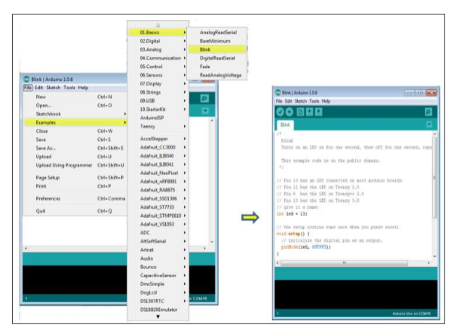
Here, we are selecting just one of the examples with the name Blink. It turns the LED on and off with some time delay. You can select any other example from the list.
Step 6: Select your Arduino board.
To avoid any error while uploading your program to the board, you must select the correct Arduino board name, which matches with the board connected to your computer.
Go to Tools -> Board and select your board.

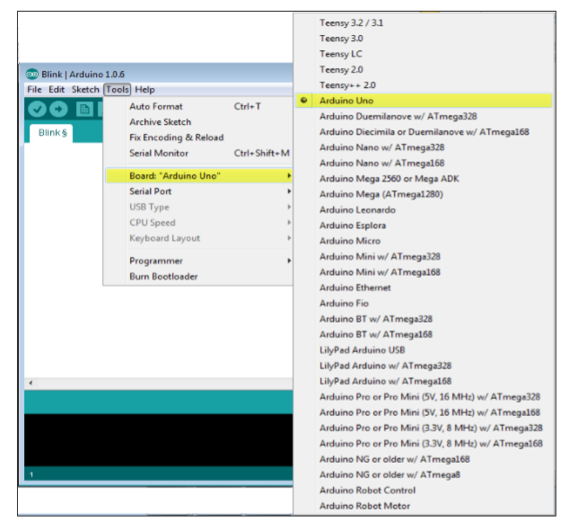

Fig 3.1.6: Selecting board in arduino
Here, we have selected Arduino Uno board according to our tutorial, but you must select the name matching the board that you are using.

Step 7: Select your serial port.
Select the serial device of the Arduino board. Go to Tools -> Serial Port menu. This is likely to be COM3 or higher (COM1 and COM2 are usually reserved for hardware serial ports). To find out, you can disconnect your Arduino board and re-open the menu, the entry that disappears should be of the Arduino board. Reconnect the board and select that serial port.

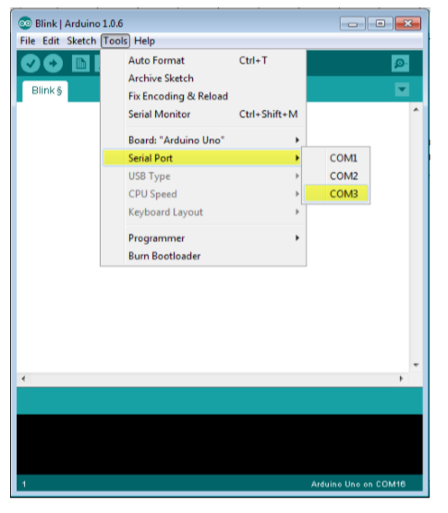

Fig 3.1.7 : Selecting serial port
Step 8: Upload the program to your board.
Before explaining how we can upload our program to the board, we must demonstrate the function of each symbol appearing in the Arduino IDE toolbar

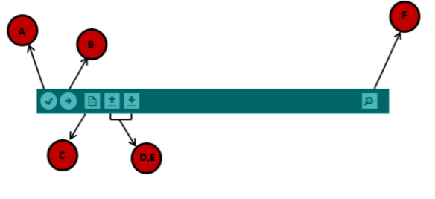
Fig 3.1.8 :Uploading program to board
A- Used to check if there is any compilation error.
B- Used to upload a program to the Arduino board.
C- Shortcut used to create a new sketch.
D- Used to directly open one of the example sketch.
E- Used to save your sketch.
F- Serial monitor used to receive serial data from the board and send the serial data to the board.
Now, simply click the "Upload" button in the environment. Wait a few seconds; you will see the RX and TX LEDs on the board, flashing. If the upload is successful, the message "Done uploading" will appear in the status bar.
Note: If you have an Arduino Mini, NG, or other board, you need to press the reset button physically on the board, immediately before clicking the upload button on the Arduino Software.

ARDUINO – PROGRAM STRUCTURE
we will study in depth, the Arduino program structure and we will learn more new terminologies used in the Arduino world. The Arduino software is open-source. The source code for the Java environment is released under the GPL and the C/C++ microcontroller libraries are under the LGPL.
Sketch: The first new terminology is the Arduino program called “sketch”.
Structure Arduino programs can be divided in three main parts: Structure, Values (variables and constants), and Functions. In this tutorial, we will learn about the Arduino software program, step by step, and how we can write the program without any syntax or compilation error.
Let us start with the Structure. Software structure consist of two main functions:
• Setup( ) function
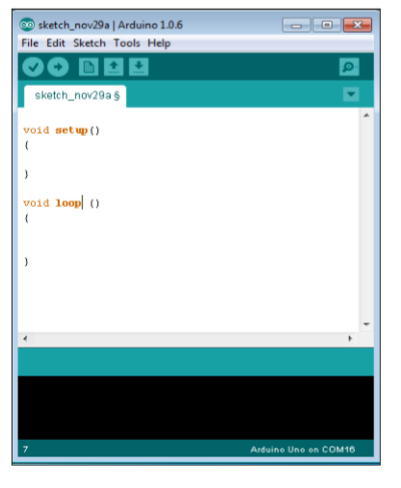
• Loop( ) function
Fig 3.1.9 : Program Structure
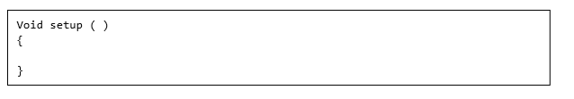
PURPOSE: The setup() function is called when a sketch starts. Use it to initialize the variables, pin modes, start using libraries, etc. The setup function will only run once, after each power up or reset of the Arduino board.
INPUT: -
OUTPUT: -
RETURN:

PURPOSE: After creating a setup() function, which initializes and sets the initial values, the loop() function does precisely what its name suggests, and loops consecutively, allowing your program to change and respond. Use it to actively control the Arduino board.
INPUT: -
OUTPUT: -
RETURN:

Applications
The proposed system can be used in various real-world scenarios to improve maternal healthcare and safety:
1. Rural Healthcare Monitoring
The device is highly useful in rural and remote areas where access to hospitals and doctors is limited. It enables continuous health monitoring without the need for frequent travel, helping reduce maternal and fetal risks.
2. Home-Based Pregnancy Care
Pregnant women can use this device at home for regular monitoring of vital parameters such as heart rate and temperature. It provides comfort, convenience, and continuous supervision without hospital dependency.
3. Remote Patient Monitoring
Doctors and healthcare providers can monitor patients remotely through IoT connectivity. This allows timely medical advice and intervention without requiring physical presence.
4. Emergency Alert System
The buzzer alert system helps detect abnormal conditions instantly and notifies the user or nearby individuals, enabling quick action during emergencies.
5. Preventive Healthcare
By continuously tracking health parameters, the system helps in early detection of complications such as fever or irregular heart rate, reducing the chances of severe health issues.
6. Hospital and Clinic Use
Hospitals can use this system for monitoring multiple patients efficiently, especially in maternity wards, reducing the workload of healthcare staff.
7. Telemedicine Applications
The device supports telemedicine by sending real-time data to doctors, allowing virtual consultations and reducing the need for physical visits.

CHAPTER 4
HARDWARE REQUIREMENTS
4.1 ARDUINO UNO
The Arduino Uno is a widely used open-source microcontroller board based on the ATmega328P microcontroller. In the proposed Smart Alert Device for Pregnant Ladies, it serves as the central processing unit (CPU) that coordinates all system operations. It acts as the bridge between input devices (sensors) and output components (LCD, buzzer, NodeMCU), ensuring smooth data flow and real-time processing.
At the hardware level, the Arduino Uno consists of multiple input/output pins that allow it to interface with various sensors and modules. It includes 14 digital I/O pins (of which 6 can be used as PWM outputs) and 6 analog input pins, which are essential for reading analog signals from sensors like temperature and heart rate sensors. The board operates at a clock speed of 16 MHz, enabling it to process data efficiently in real time. It also has built-in features such as a USB interface for programming, a power jack, voltage regulators, and onboard memory including Flash memory (32 KB), SRAM (2 KB), and EEPROM (1 KB).
In this system, the Arduino continuously receives raw signals from the connected sensors. For example, the temperature sensor provides analog voltage proportional to body temperature, and the heart rate sensor generates pulse signals based on blood flow. The Arduino converts these analog signals into digital values using its Analog-to-Digital Converter (ADC). It then processes these values using programmed logic and compares them with predefined threshold limits to determine whether the readings are normal or abnormal.
Based on this analysis, the Arduino performs multiple control actions simultaneously. It sends processed data to the LCD display for real-time visualization, triggers the buzzer if any abnormal condition is detected, and communicates with the NodeMCU module through serial communication to transmit data to the cloud. This multi-tasking capability makes Arduino highly suitable for embedded healthcare applications.
Another important aspect of the Arduino Uno is its ease of programming and flexibility. It is programmed using the Arduino IDE, which supports Embedded C/C++ language. The platform provides a wide range of libraries for sensors, displays, and communication modules, making development faster and more efficient. Additionally, Arduino supports rapid prototyping, allowing developers to easily test and modify the system.

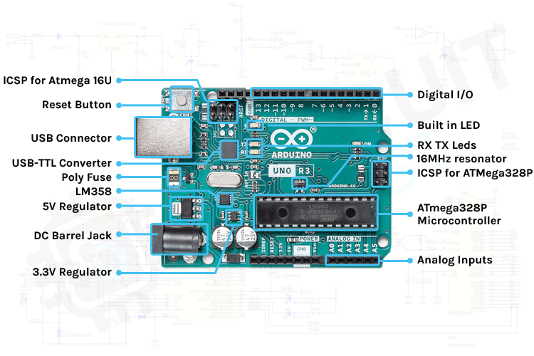
Fig 4.1: Arduino uno
Source : https://circuitdigest.com/article/everything-you-need-to-know-about-arduino-uno-board-hardware

The Arduino Uno is also known for its low cost, low power consumption, and reliability, making it ideal for portable and continuous monitoring systems. Its open-source nature allows easy customization and integration with additional modules, enabling future enhancements such as adding more sensors or upgrading to advanced features.
Overall, the Arduino Uno plays a crucial role in the proposed system by performing data acquisition, processing, decision-making, and control operations, thereby ensuring accurate, real-time, and reliable health monitoring for pregnant women.

The Arduino Uno consists of 14 digital input/output pins, out of which 6 can be used as PWM outputs, and 6 analog input pins. It also includes a USB connection, power jack, reset button, and crystal oscillator. These features make it suitable for controlling multiple devices and performing real-time operations.

The microcontroller on the Arduino Uno processes the input data received from sensors and generates corresponding output signals. It operates at a clock speed of 16 MHz, which is sufficient for most embedded applications. The board can be powered either through a USB cable or an external power supply, making it flexible for different usage conditions.
One of the main advantages of the Arduino Uno is its ease of programming. It can be programmed using the Arduino IDE with simple code. The availability of a large number of libraries and community support makes development faster and easier.

In this project, the Arduino Uno plays a key role in collecting data from sensors such as the heart rate sensor, temperature sensor, and MEMS sensor. It processes this data and displays the output on the LCD. It also controls the buzzer to generate alerts when abnormal conditions are detected.

Another important feature of the Arduino Uno is its reliability and stability in continuous operation. It is capable of running for long durations without failure, which is essential for real-time health monitoring systems. Its compact size and low cost make it suitable for portable and affordable healthcare devices.

CHAPTER 5
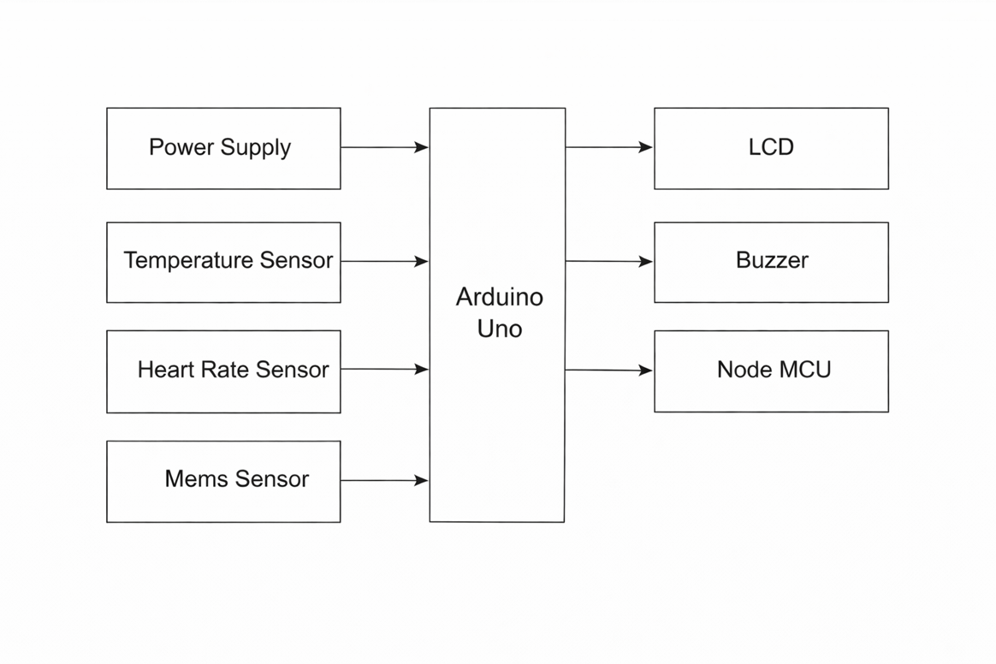
BLOCK DIAGRAM & WORKING
Fig 5.1.1: Block diagram of smart alert device for pregnant ladies

In this block diagram, the system consists of a power supply unit, Arduino UNO, NodeMCU, heart rate sensor, temperature sensor, MEMS sensor, LCD display, and buzzer. The sensors continuously monitor the user’s vital parameters such as heart rate, body temperature, and movement. The collected data is processed by the Arduino UNO and displayed on the LCD in real time. The NodeMCU module enables IoT-based communication to send the data to caregivers or doctors for remote monitoring. If any abnormal condition is detected, the system activates the buzzer to provide an immediate alert, ensuring quick response and improved safety for the user.

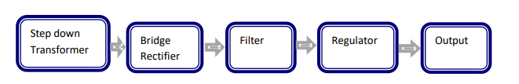
POWER SUPPLY
Fig 5.1.2: power supply

Tools Used
Hardware Tools
- Arduino Uno
- NodeMCU (ESP8266)
- Temperature Sensor
- Heart Rate Sensor
- MEMS Sensor
- LCD Display (16x2)
- Buzzer
- Power Supply
- Breadboard
- Connecting Wires
Software Tools
- Arduino IDE
- Embedded C Programming
Inputs and Outputs
Inputs
The system collects physiological and motion data using the following sensors:
- Temperature Sensor
Measures the body temperature of the pregnant woman to detect fever or abnormal conditions.
- Heart Rate Sensor
Measures the heart rate in Beats Per Minute (BPM) to monitor cardiac health.
- MEMS Sensor
Detects movement, posture, or activity, which can help in identifying unusual body conditions.
- Power Supply
Provides the necessary electrical power to all components in the system.
Outputs
The processed data is provided through the following output components:
- LCD Display (16x2)
Displays real-time values such as temperature, heart rate, and system status.
- Buzzer
Generates an alert sound when abnormal conditions (e.g., high temperature or irregular heart rate) are detected.
- NodeMCU (IoT Output)
Transmits the collected data to a remote server/cloud, enabling doctors or caregivers to monitor the patient remotely.
Working Principle
The proposed Smart Alert Device for Pregnant Ladies is designed to function as a real-time health monitoring and alert system by integrating sensor technology with Internet of Things (IoT) communication. The operation of the system begins with the power supply unit, which provides a stable and regulated voltage to all hardware components, including sensors, the Arduino microcontroller, LCD display, buzzer, and NodeMCU module. This ensures continuous and reliable functioning of the entire system without interruptions.
Once powered, the system activates multiple sensors such as the temperature sensor, heart rate sensor, and MEMS sensor. These sensors continuously monitor important physiological and motion-related parameters of the pregnant woman. The temperature sensor measures the body temperature to detect fever or abnormal thermal conditions, while the heart rate sensor captures the pulse rate in beats per minute (BPM), which is crucial for assessing cardiovascular health. The MEMS sensor detects movement, orientation, and activity patterns, which can help identify unusual conditions such as sudden falls or lack of movement.
The collected sensor data is transmitted to the Arduino microcontroller, which serves as the central processing unit of the system. The Arduino reads the analog or digital signals from the sensors, processes them, and converts them into meaningful values. It then compares these values with predefined threshold limits stored in the program. These threshold values represent normal and safe ranges for each parameter. Based on this comparison, the system determines whether the current condition of the user is normal or requires attention.
The processed data is displayed on a 16x2 LCD screen, providing real-time feedback to the user. This allows the pregnant woman or caregiver to continuously observe vital health parameters without requiring any additional devices. In situations where any parameter exceeds or falls below the safe threshold range, the Arduino immediately triggers the buzzer. This acts as an instant alert mechanism, notifying the user and nearby individuals about the abnormal condition, thereby enabling quick response and preventive action.
In addition to local monitoring and alerting, the system incorporates a NodeMCU (ESP8266) module to enable wireless communication. The NodeMCU connects to a Wi-Fi network and transmits the collected sensor data to a remote server or cloud platform. This allows healthcare professionals or family members to monitor the patient’s health status from any location in real time. The remote monitoring feature is particularly beneficial for pregnant women in rural or remote areas, as it reduces the need for frequent hospital visits while still ensuring continuous medical supervision.
Overall, the system operates in a seamless cycle of data acquisition, processing, alert generation, and data transmission. By combining real-time monitoring with immediate alert mechanisms and remote accessibility, the proposed device enhances maternal healthcare management, supports early detection of potential risks, and contributes to improved safety and well-being of both the mother and the fetus.
Step down Transformer:
A Stepdown Transformer is the one which reduces the output voltage that means it functions for converting high voltage with low current into a low voltage with high current. Usually, DC voltages are required to operate various electronic equipment and these voltages are 5V, 9V or 12V. But these voltages cannot be obtained directly. Thus, the a.c input available at the mains supply i.e., 230V is to be brought down to the required voltage level. This is done by a transformer. Thus, a stepdown transformer is employed to decrease the voltage to a required level.
Depending on the different areas sometimes, voltages are stepped down to 230v or 440v for the safety reasons.
But to make this reduction in voltages a reality, the number of turns on secondary winding or coils is kept less than the primary winding or coils that ultimately result in less voltage being induced at the secondary output of the transformer.

Rectifier:
The output from the transformer is fed to the rectifier. It converts A.C. into pulsating D.C. The rectifier may be a half wave or a full wave rectifier. In this project, a bridge rectifier is used because of its merits like good stability and full wave rectification.
The process is known as rectification, since it "straightens" the direction of current. Rectifiers have many uses, but are often found serving as components of DC power supplies and high-voltage direct current power transmission systems. Depending on the type of alternating current supply and the arrangement of the rectifier circuit, the output voltage may require additional smoothing to produce a uniform steady voltage.

Filter:
Capacitive filter is used in this project. In power supplies, capacitors are used to smooth (filter) the pulsating DC output after rectification so that a nearly constant DC voltage is supplied to the load. The pulsating output of the rectifiers has an average DC value and an AC portion that is called ripple voltage. Filter capacitors reduce the amount of ripple voltage to a level that is acceptable. In a filter circuit the capacitor is charged to the peak of the rectified input voltage during the positive portion of the input. When the input goes negative, the capacitor begins to discharge into the load. It removes the ripples from the output of rectifier and smoothens the D.C. Output received from this filter is constant until the mains voltage and load is maintained constant. However, if either of the two is varied, D.C. voltage received at this point changes. Therefore, a regulator is applied at the output stage.

Voltage Regulator:
As the name itself implies, it regulates the input applied to it. A voltage regulator is an electrical regulator designed to automatically maintain a constant voltage level. The voltage regulator monitors the current drawn by the load and increases or decreases the voltage accordingly to keep the voltage level constant. A voltage regulator may use a simple feed-forward design or may include negative feedback. It may use an electromechanical mechanism, or electronic components. Depending on the design, it may be used to regulate one or more AC or DC voltages. In this project, power supply of 5V and 12V are required. In order to obtain these voltage levels, 7805 and 7812 voltage regulators are to be used. The first number 78 represents positive supply and the numbers 05, 12 represent the required output voltage levels. The most popular type of voltage regulator IC is the 78XX series, sometimes called the LM78XX series.

Features:
• Output Current up to 1A.
• Output Voltages of 5, 6, 8, 9, 10, 12, 15, 18, 24V.
• Thermal Overload Protection.
• Short Circuit Protection.
• Output Transistor Safe Operating Area Protection.
3.3 NodeMCU (ESP8266)
The NodeMCU (ESP8266) is a powerful, low-cost, Wi-Fi-enabled microcontroller widely used in Internet of Things (IoT) applications. In the proposed Smart Alert Device for Pregnant Ladies, the NodeMCU plays a crucial role in enabling wireless communication and remote health monitoring. It allows the system to connect to a Wi-Fi network and transmit real-time sensor data to a remote server or cloud platform, making the healthcare system accessible from anywhere in the world.
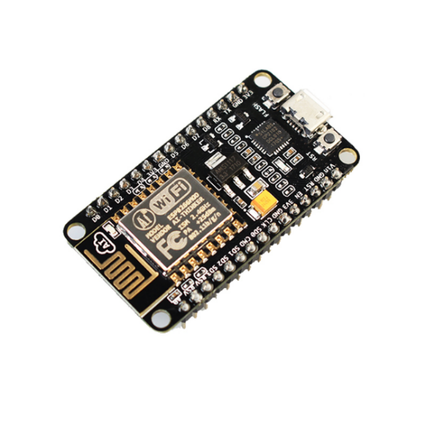
The NodeMCU is built around the ESP8266 chip, which has an integrated TCP/IP protocol stack, enabling it to handle internet communication efficiently without requiring additional hardware. It supports standard communication protocols such as HTTP, MQTT, and TCP/UDP, which are commonly used for sending sensor data to cloud platforms like ThingSpeak or Blynk. This makes it highly suitable for real-time healthcare monitoring systems.

Fig 5.3:NodeMCU
Source:https://imgconvert.csdnimg.cn/aHR0cHM6Ly9nZDEuYWxpY2RuLmNvbS9pbWdleHRyYS9pMS8yOTIyNjIxMjk3L08xQ04wMXZOajJORTFMUzRFVlNpWlhEXyEhMjkyMjYyMTI5Ny5qcGc?x-oss-process=image/format,png

In the proposed system, the NodeMCU communicates with the Arduino microcontroller through serial communication (UART protocol). The Arduino collects and processes sensor data from temperature, heart rate, and MEMS sensors, and then sends this data to the NodeMCU. The NodeMCU receives the data, formats it, and transmits it over the internet to a cloud server. This seamless communication ensures continuous data flow between the local device and remote monitoring systems.
One of the major advantages of the NodeMCU is its built-in Wi-Fi capability, which eliminates the need for external communication modules. It also supports secure communication features, allowing encrypted data transmission to protect sensitive health information. Additionally, the NodeMCU is programmable using the Arduino IDE, making it easy to integrate into embedded systems.
The NodeMCU also offers multiple GPIO pins, analog input, PWM, and interrupt capabilities, allowing it to interface with sensors and other devices directly if required. Although in this system it is primarily used as a communication module, it can also act as a standalone microcontroller, reducing the need for Arduino in advanced designs.
Furthermore, the NodeMCU operates at low power consumption, making it suitable for portable and wearable healthcare devices. Its compact size and affordability make it an ideal choice for cost-effective IoT solutions, especially in rural healthcare applications.
Overall, the NodeMCU enhances the system by providing real-time data transmission, remote accessibility, scalability, and reliability, making it a key component in modern smart healthcare monitoring systems.

Temperature Sensor
The temperature sensor plays a vital role in the Smart Alert Device for Pregnant Ladies by continuously monitoring the body temperature of the user. Maintaining a normal body temperature during pregnancy is essential, as even slight variations may indicate underlying health issues such as infections, inflammation, or fever. Sensors like LM35 and MAX30205 are commonly used due to their high accuracy, reliability, and ease of integration with microcontrollers such as Arduino.
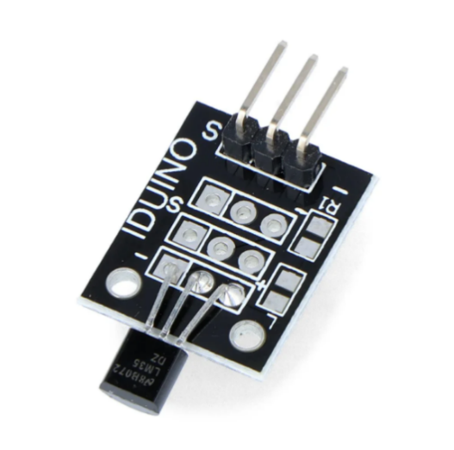
The LM35 temperature sensor is an analog device that provides an output voltage directly proportional to the temperature in degrees Celsius. It does not require calibration and offers a typical accuracy of ±0.5°C. The sensor outputs a linear voltage (10 mV per °C), which is read by the Arduino’s analog input pin and converted into temperature values using simple calculations. Due to its simplicity and low cost, LM35 is widely used in embedded systems and academic projects.

Fig 5.4: Temperature Sensor
Source : https://5.imimg.com/data5/SELLER/Default/2023/12/367261409/BD/KN/FV/562456/lm35dz-module-500x500.webp

On the other hand, the MAX30205 sensor is a digital temperature sensor specifically designed for human body temperature measurement. It provides high precision (±0.1°C accuracy) and communicates with the microcontroller using the I2C protocol. This makes it more suitable for medical-grade applications where accurate body temperature monitoring is required. The sensor directly sends digital temperature data, eliminating the need for analog-to-digital conversion.
In the proposed system, the temperature sensor is placed in contact with the user’s body (such as finger, skin surface, or wearable form) to continuously capture temperature readings. These readings are sent to the Arduino microcontroller, where they are processed and compared with predefined threshold values. Typically, the normal human body temperature ranges between 36.5°C to 37.5°C (97°F to 99°F). If the temperature exceeds this range (for example, above 38°C indicating fever), the system identifies it as an abnormal condition.
When such abnormality is detected, the Arduino immediately triggers the buzzer to alert the user. Simultaneously, the data is displayed on the LCD screen and transmitted via the NodeMCU module to a remote server for further monitoring by doctors or caregivers. This ensures timely medical attention and helps prevent complications during pregnancy.
Additionally, continuous temperature monitoring allows for trend analysis, where gradual increases or fluctuations in temperature can be observed over time. This is particularly useful for early detection of infections or other health conditions that may not show immediate symptoms. The integration of temperature sensors in the system thus enhances preventive healthcare, improves safety, and supports better medical decision-making.
Overall, the temperature sensor serves as a critical component in the system by enabling accurate, real-time, and continuous monitoring of body temperature, thereby contributing significantly to maternal health management.
Heart Rate Sensor
The heart rate sensor is an essential component in the proposed Smart Alert Device for Pregnant Ladies, as it continuously monitors the pulse rate of the user in Beats Per Minute (BPM). It plays a crucial role in assessing cardiovascular health and identifying abnormalities that may pose risks during pregnancy.
Working Principle (Photoplethysmography - PPG)
The heart rate sensor operates based on a technique called Photoplethysmography (PPG). This method uses a light source (usually an LED) and a photodetector to measure variations in blood volume. When the sensor is placed on a fingertip or earlobe, the LED emits light into the skin. As the heart pumps blood, the volume of blood in the vessels changes periodically, affecting the amount of light absorbed or reflected.
- During a heartbeat, more blood flows → more light is absorbed
- Between beats, less blood flows → more light is reflected
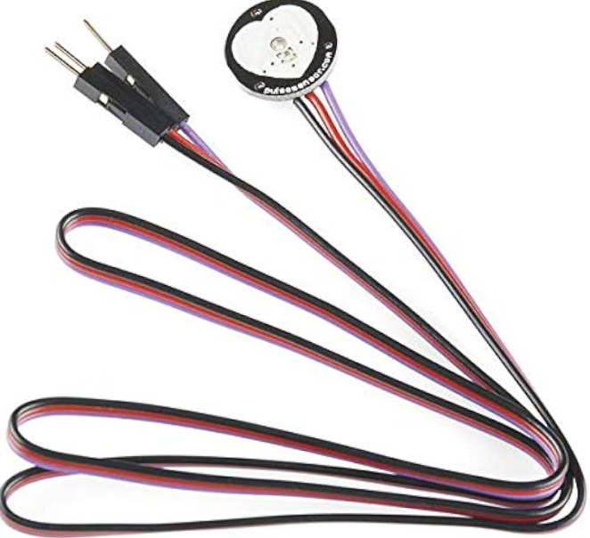
These variations are detected by the photodiode and converted into electrical signals. The microcontroller processes these signals to calculate the pulse rate in BPM.

Fig 5.5: Heart rate Sensor
Source : https://5.imimg.com/data5/UM/DM/MY-4167793/pulse-sensor-1000x1000.jpg

How It Works in Your System
- The sensor is placed on the user’s fingertip.
- It continuously detects blood flow changes.
- Analog signals are sent to the Arduino.
- Arduino processes the signal and calculates BPM.
- The result is displayed on the LCD and monitored for abnormal values.
Normal Heart Rate Range (Pregnancy Context)
- Typical adult resting heart rate: 60 – 100 BPM
- During pregnancy: may increase to 70 – 110 BPM
- Abnormal conditions:
  - Too high (Tachycardia) → Possible stress, fever, or complications
  - Too low (Bradycardia) → Possible weakness or medical concern
Importance in Pregnancy Monitoring
Monitoring heart rate is very important because:
- Helps detect cardiac abnormalities
- Indicates stress or anxiety levels
- Helps identify fever or infection indirectly
- Supports early detection of pregnancy complications
- Ensures both maternal and fetal safety
Advantages of Heart Rate Sensor
- Non-invasive and easy to use
- Real-time monitoring capability
- Low cost and compact size
- Can be integrated easily with Arduino and IoT systems
Limitations
- Accuracy may be affected by:
  - Finger movement
  - Improper placement
  - External light interference
- Not as precise as medical-grade ECG devices
Additional Technical Insight
- The sensor outputs analog pulse signals (waveform)
- Arduino uses signal processing (peak detection) to calculate BPM
- Sampling and filtering techniques improve accuracy
- Can be enhanced with:
  - Digital filtering
  - AI-based anomaly detection (future scope)
The heart rate sensor is a vital component that enables continuous and non-invasive monitoring of cardiovascular activity. By using light-based sensing technology, it provides real-time pulse data, which helps in early detection of abnormalities and ensures timely medical intervention, thereby improving the safety and health management of pregnant women.
3.6 MEMS Sensor
The MEMS (Micro-Electro-Mechanical System) sensor is a highly compact and intelligent device that integrates mechanical elements, sensors, actuators, and electronics on a single microchip. In the proposed Smart Alert Device for Pregnant Ladies, the MEMS sensor is primarily used to detect motion, orientation, tilt, and activity levels of the pregnant woman. It plays a crucial role in monitoring physical behavior and identifying abnormal situations that may pose health risks.
Working Principle
The MEMS sensor, such as the commonly used MPU6050, combines an accelerometer and a gyroscope:
- Accelerometer
Measures linear acceleration along three axes (X, Y, Z). It detects:
  - Movement
  - Tilt
  - Sudden changes in position
- Gyroscope
Measures angular velocity, which helps determine:
  - Rotation
  - Orientation changes
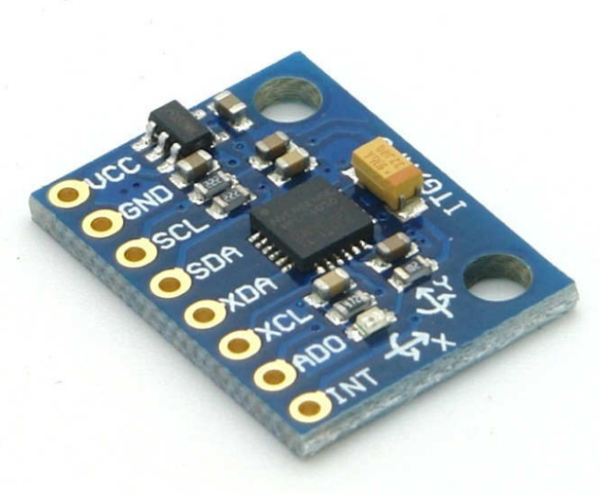
Inside the MEMS sensor, tiny mechanical structures (micro-scale) move when acceleration or motion occurs. These movements cause changes in electrical signals, which are converted into digital data and sent to the Arduino for processing.
Fig 5.6: MEMS sensor
Source:https://www.electronicwings.com/storage/PlatformSection/TopicContent/371/description/MPU6050%20Module.jpg

Role in the Proposed System
In your project, the MEMS sensor is used to:
- Monitor body movement and posture
- Detect sudden falls or unusual activity
- Identify lack of movement (inactivity), which may indicate discomfort or risk
- Provide additional health insights beyond basic physiological parameters
This makes the system more intelligent and safety-oriented, as it not only measures vital signs but also tracks physical behavior.
Importance for Pregnant Women
The MEMS sensor is particularly useful in maternal healthcare because:
- Sudden falls during pregnancy can be dangerous
- Reduced movement may indicate fatigue or health issues
- Continuous posture monitoring helps ensure safe physical activity
By detecting these conditions early, the system can trigger alerts and prevent complications.
Technical Features of MPU6050 (Example MEMS Sensor)
- 6-axis motion tracking (3-axis accelerometer + 3-axis gyroscope)
- Digital output via I2C communication
- Built-in Digital Motion Processor (DMP)
- High sensitivity and accuracy
- Low power consumption
- Compact and lightweight
Advantages
- Small size and lightweight
- High accuracy in motion detection
- Low power consumption
- Real-time activity monitoring
- Enhances safety with fall detection
Limitations
- Requires calibration for accurate readings
- Sensitive to noise and vibrations
- May produce errors if not properly positioned
The MEMS sensor significantly enhances the functionality of the proposed system by enabling motion-based monitoring in addition to physiological parameter tracking. Its ability to detect movement, posture, and sudden changes makes it an essential component for ensuring the safety and well-being of pregnant women, especially in remote monitoring scenarios.
3.7 LCD Display (16x2)
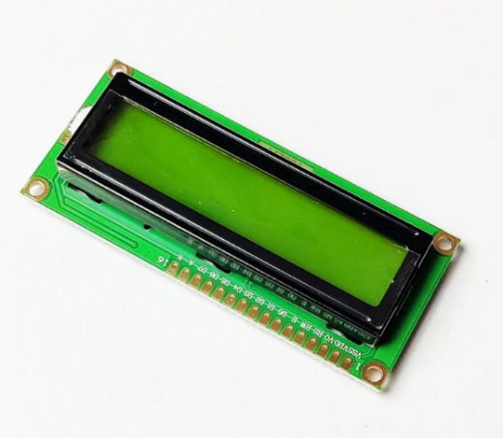
The 16×2 LCD display is an essential output component in the Smart Alert Device for Pregnant Ladies, used to present real-time information in a clear and readable format.

Fig 5.7 : LCD Display
Source : https://m.media-amazon.com/images/I/41SztWPiL6L._SY445_SX342_QL70_ML2_.jpg
It is capable of displaying 16 characters per line across two lines, making it suitable for showing multiple health parameters simultaneously, such as temperature, heart rate (BPM), and system status messages like “Normal” or “Alert.” This immediate visual feedback allows the user or caregiver to continuously monitor the patient’s condition without needing external devices like smartphones or computers.

Working Principle
The 16×2 LCD typically operates based on the HD44780 controller, which manages how characters are displayed on the screen. The display works by controlling liquid crystals that either block or allow light to pass through, forming visible characters. When interfaced with the Arduino, data is sent in either 4-bit or 8-bit mode, where digital signals from the microcontroller are converted into readable text on the screen.
Pin Configuration
The LCD module generally consists of 16 pins, each serving a specific function:
- VSS & VCC – Ground and power supply (5V)
- VEE – Controls contrast (adjusted using a potentiometer)
- RS (Register Select) – Selects command or data mode
- RW (Read/Write) – Selects read or write operation
- EN (Enable) – Triggers data processing
- D0–D7 – Data pins for sending information
- A & K – Backlight LED (Anode & Cathode)
Interfacing with Arduino
The LCD is commonly connected to the Arduino using digital I/O pins. To simplify programming, the LiquidCrystal library is used, which allows easy control of the display. In many projects, 4-bit mode is preferred because it reduces the number of required connections while maintaining efficient performance.
Features of 16×2 LCD
- Low power consumption
- Easy to interface with microcontrollers
- Compact and cost-effective
- Built-in backlight for visibility in low light
- Supports custom characters
- Reliable and widely available
Role in Your Project
In the proposed system, the LCD plays a vital role by:
- Displaying live sensor values (temperature, heart rate)
- Showing system messages (e.g., “Monitoring…”, “Abnormal Condition”)
- Helping users quickly understand the health status
- Reducing dependency on external monitoring systems
Advantages in Healthcare Monitoring
The inclusion of an LCD display enhances usability by providing instant and continuous feedback. It is especially useful in rural or home environments where advanced devices may not be available. The display ensures that even non-technical users can easily interpret the health data and take necessary actions when alerts are triggered.
The 16×2 LCD display serves as a simple yet powerful interface in the system, bridging the gap between complex sensor data and user understanding. Its reliability, affordability, and ease of use make it an ideal choice for real-time health monitoring applications.
Buzzer
The buzzer is an important output component in the Smart Alert Device for Pregnant Ladies, designed to provide immediate audible alerts whenever abnormal health conditions are detected. It acts as a warning system that ensures the user or nearby individuals are instantly informed about potential risks without needing to continuously monitor the display.
In this system, the buzzer is controlled by the Arduino microcontroller. When the sensor data (such as temperature or heart rate) exceeds predefined safe threshold values, the Arduino sends a signal to activate the buzzer. This produces a sound alert, which can vary depending on the programming logic—such as continuous beeping for critical conditions or intermittent beeps for moderate warnings. This differentiation helps in identifying the severity of the situation.
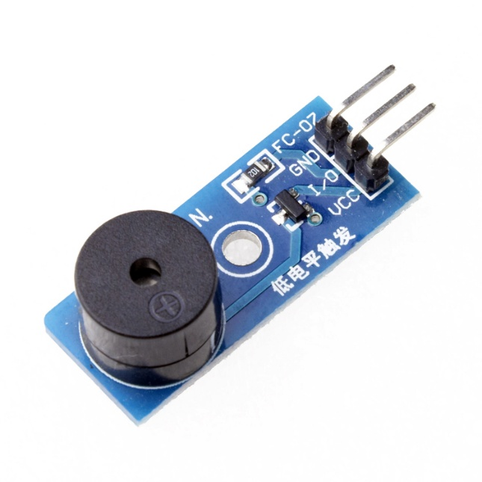

Fig 5.8 : Buzzer module
Source : https://circuit-electronics.com/wp-content/uploads/2022/06/1463640482_grobo.jpg

Working Principle of Buzzer
A buzzer typically works based on the piezoelectric effect, where an electrical signal is converted into mechanical vibrations to produce sound. When voltage is applied, the piezoelectric material inside the buzzer vibrates rapidly, generating audible tones.
There are two main types of buzzers:
- Active Buzzer
  - Has a built-in oscillator
  - Produces sound directly when power is supplied
  - Easy to use in simple alert systems
- Passive Buzzer
  - Requires an external signal (PWM) to generate sound
  - Allows different tones and patterns
  - More flexible for advanced alert systems
In your project, an active buzzer is typically used due to its simplicity and ease of integration.
Role in the Proposed System
The buzzer plays a critical safety role in the system:
- Alerts when heart rate is too high or too low
- Warns when body temperature exceeds normal range
- Can indicate abnormal movement or inactivity (via MEMS sensor)
- Provides instant notification without internet dependency
This is especially useful in:
- Rural areas
- Emergency situations
- Cases where the user is not actively checking the LCD
Advantages of Using a Buzzer
- Provides instant and real-time alerts
- Works even without internet connectivity
- Simple and low-cost component
- Low power consumption
- Easy to interface with Arduino
- Improves system responsiveness and safety
Additional Enhancements (Optional for Your Paper)
You can improve the buzzer functionality by:
- Using different beep patterns for different conditions
- Integrating with LED indicators for visual alerts
- Adding SMS/notification alerts along with buzzer
- Using voice alert modules for more informative warnings
The buzzer serves as a crucial alert mechanism in the proposed system by providing immediate audio feedback during abnormal health conditions. Its simplicity, reliability, and effectiveness make it an essential component for ensuring timely intervention and enhancing the overall safety of pregnant women.
3.9 Internet of Things-IOT:
The IOT concept was coined by a member of the Radio Frequency Identification (RFID) development community in 1999, and it has recently become more relevant to the practical world largely because of the growth of mobile devices, embedded and ubiquitous communication, cloud computing and data analytics. Imagine a world where billions of objects can sense, communicate and share information, all interconnected over public or private Internet Protocol (IP) networks. These interconnected objects have data regularly collected, analysed and used to initiate action, providing a wealth of intelligence for planning, management and decision making. This is the world of the Internet of Things (IOT). Internet of things common definition is defining as: Internet of things (IOT) is a network of physical objects. The internet is not only a network of computers, but it has evolved into a network of device of all type and sizes , vehicles, smart phones, home appliances, toys, cameras, medical instruments and industrial systems, animals, people, buildings, all connected ,all communicating & sharing information based on stipulated protocols in order to achieve smart reorganizations, positioning, tracing, safe & control & even personal real time online monitoring , online upgrade, process control & administration We define IOT into three categories as below: Internet of things is an internet of three things People to people, People to machine /things, Things /machine to things machine, Interacting through internet. Internet of Things Vision: Internet of Things (IoT) is a concept and a paradigm that considers pervasive presence in the environment of a variety of things/objects that through wireless and wired connections and unique addressing schemes are able to interact with each other and cooperate with other things/objects to create new applications/services and reach common goals. In this context the research and development challenges to create a smart world are enormous. A world where the real, digital and the virtual are converging to create smart environments that make energy, transport, cities and many other areas more intelligent.



Fig 5.9: Internet Of Things
Source:https://encryptedtbn0.gstatic.com/images?q=tbn:ANd9GcRXtrcT_kSzfv21J2V6yHHN7XvL_kLbL3NHBA&s

Internet of Things is refer to the general idea of things, especially everyday objects, that are readable, recognisable, locatable, addressable through information sensing device and/or controllable via the Internet, irrespective of the communication means (whether via RFID, wireless LAN, wide area networks, or other means). Everyday objects include not only the electronic devices we encounter or the products of higher technological development such as vehicles and equipment but things that we do not ordinarily think of as electronic at all - such as food , clothing ,chair, animal, tree, water etc. Internet of Things is a new revolution of the Internet. Objects make themselves recognizable and they obtain intelligence by making or enabling context related decisions thanks to the fact that they can communicate information about themselves. They can access information that has been aggregated by other things, or they can be components of complex services. This transformation is concomitant with the emergence of cloud computing capabilities and the transition of the Internet towards IPv6 with an almost unlimited addressing capacity. The goal of the Internet of Things is to enable things to be connected anytime, anyplace, with anything and anyone ideally using any path/network and any service.
II. ENABLING TECHNOLOGIES FOR IOT
Internet of things (IoT) is a global infrastructure for the information society, enabling advanced services by interconnecting (physical and virtual) things based on existing and evolving interoperable information and communication technologies. With the Internet of Things the communication is extended via Internet to all the things that surround us. The Internet of Things is much more than machine to machine communication, wireless sensor networks, sensor networks , 2G/3G/4G,GSM,GPRS,RFID, WI-FI, GPS, microcontroller, microprocessor etc. These are considered as being the enabling technologies that make “Internet of Things” applications possible. Enabling technologies for the Internet of Things are considered in and can be grouped into three categories: (1) technologies that enable “things” to acquire contextual information, (2) technologies that enable “things” to process contextual information, and (3) technologies to improve security and privacy. The first two categories can be jointly understood as functional building blocks required building “intelligence” into “things”, which are indeed the features that differentiate the IoT from the usual Internet. The third category is not a functional but rather a de facto requirement, without which the penetration of the IoT would be severely reduced The Internet of Things is not a single technology, but it is a mixture of different hardware & software technology. The Internet of Things provides solutions based on the integration of information technology, which refers to hardware and software used to store, retrieve, and process data and communications technology which includes electronic systems used for communication between individuals or groups. There is a heterogeneous mix of communication technologies, which need to be adapted in order to address the needs of IoT applications such as energy efficiency, speed, security, and reliability. In this context, it is possible that the level of diversity will be scaled to a number a manageable connectivity technologies that address the needs of the IoT applications, are adopted by the market, they have already proved to be serviceable, supported by a strong technology alliance. Examples of standards in these categories include wired and wireless technologies like Ethernet, WI-FI, Bluetooth, ZigBee, GSM, and GPRS. [1, 2] The key enabling technologies for the Internet of Things is presented in Figure 2.
III. CHARACTERISTICS
The fundamental characteristics of the IoT are as follows
Interconnectivity:
With regard to the IoT, anything can be interconnected with the global information and communication infrastructure.
Things-related services: The IoT is capable of providing thing-related services within the constraints of things, such as privacy protection and semantic consistency between physical things and their associated virtual things. In order to provide thing-related services within the constraints of things, both the technologies in physical world and information world will change.
Heterogeneity: The devices in the IoT are heterogeneous as based on different hardware platforms and networks. They can interact with other devices or service platforms through different networks.
Dynamic changes: The state of devices change dynamically, e.g., sleeping and waking up, connected and/or disconnected as well as the context of devices including location and speed. Moreover, the number of devices can change dynamically.
Enormous scale: The number of devices that need to be managed and that communicate with each other will be at least an order of magnitude larger than the devices connected to the current Internet. Even more critical will be the management of the data generated and their interpretation for application purposes. This relates to semantics of data, as well as efficient data handling.
Safety: As we gain benefits from the IoT, we must not forget about safety. As both the creators and recipients of the IoT, we must design for safety. This includes the safety of our personal
data and the safety of our physical well-being. Securing the endpoints, the networks, and the data moving across all of it means creating a security paradigm that will scale.
Connectivity: Connectivity enables network accessibility and compatibility. Accessibility is getting on a network while compatibility provides the common ability to consume and produce data.
Interoperability: Interoperability is an important feature of IoT systems, which allows different devices and technologies to work together efficiently. It ensures that devices from different manufacturers can communicate, exchange data, and operate using common standards and protocols. This feature enhances system flexibility and makes it easier to integrate new devices into the existing network. As a result, the overall performance of the system improves, and users can experience smooth and reliable operation without compatibility issues. Moreover, interoperability supports scalability and future expansion of IoT applications.
Energy Efficiency: Energy efficiency is a key aspect of IoT systems, as many devices operate on limited power sources such as batteries. Optimizing power consumption helps in extending the lifetime of devices and ensures continuous operation without frequent maintenance.

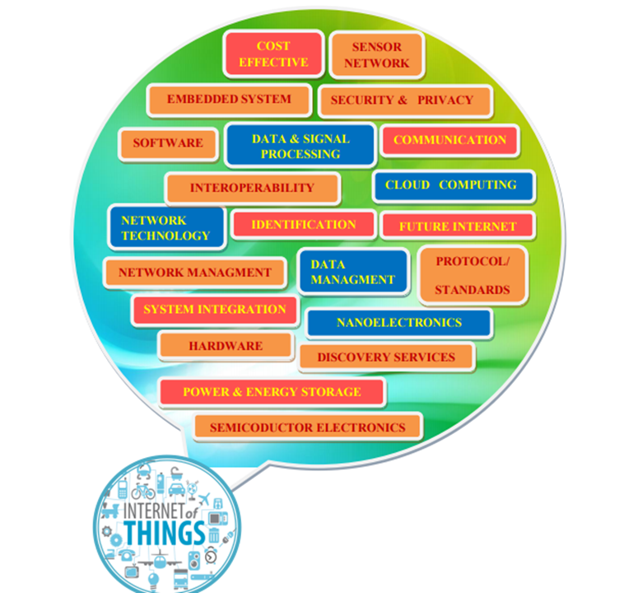

Fig 5.9.2: Fundamentals of IOT
Source:https://encryptedtbn0.gstatic.com/images?q=tbn:ANd9GcTdqxyr7fmFKpAGsPxxV7AZUmRTNBLRE1qdQ&s
IV. IOT ARCHITECTURE
IOT architecture consists of different layers of technologies supporting IOT. It serves to illustrate how various technologies relate to each other and to communicate the scalability, modularity and configuration of IOT deployments in different scenarios. Figure 4 shows detailed architecture of IOT. The functionality of each layer is described below
- smart device / sensor layer:
The lowest layer is made up of smart objects integrated with sensors. The sensors enable the interconnection of the physical and digital worlds allowing real-time information to be collected and processed. There are various types of sensors for different purposes. The sensors have the capacity to take measurements such as temperature, air quality, speed, humidity, pressure, flow, movement and electricity etc. In some cases, they may also have a degree of memory, enabling them to record a certain number of measurements. A sensor can measure the physical property and convert it into signal that can be understood by an instrument. Sensors are grouped according to their unique purpose such as environmental sensors, body sensors, home appliance sensors and vehicle telematics sensors, etc. Most sensors require connectivity to the sensor gateways. This can be in the form of a Local Area Network (LAN) such as Ethernet and Wi-Fi connections or Personal Area Network (PAN) such as ZigBee, Bluetooth and Ultra Wideband (UWB). For sensors that do not require connectivity to sensor aggregators, their connectivity to backend servers/applications can be provided using Wide Area Network (WAN) such as GSM, GPRS and LTE. Sensors that use low power and low data rate connectivity, they typically form networks commonly known as wireless sensor networks (WSNs). WSNs are gaining popularity as they can accommodate far more sensor nodes while retaining adequate battery life and covering large areas.
- Gateways and Networks
Massive volume of data will be produced by these tiny sensors and this requires a robust and high performance wired or wireless network infrastructure as a transport medium. Current networks, often tied with very different protocols, have been used to support machine-to-machine (M2M) networks and their applications. With demand needed to serve a wider range of IOT services and applications such as high speed transactional services, context-aware applications, etc., multiple networks with various technologies and access protocols are needed to work with each other in a heterogeneous configuration. These networks can be in the form of a private, public or hybrid models and are built to support the communication requirements for latency, bandwidth or security. Various gateways (microcontroller, microprocessor...) & gateway networks (WI-FI, GSM, GPRS…) are shown in figure.
- Management Service Layer
The management service renders the processing of information possible through analytics, security controls, process modelling and management of devices.
One of the important features of the management service layer is the business and process rule engines. IOT brings connection and interaction of objects and systems together providing information in the form of events or contextual data such as temperature of goods, current location and traffic data. Some of these events require filtering or routing to post processing systems such as capturing of periodic sensory data, while others require response to the immediate situations such as reacting to emergencies on patient’s health conditions. The rule engines support the formulation of decision logics and trigger interactive and automated processes to enable a more responsive IOT system.
In the area of analytics, various analytics tools are used to extract relevant information from massive amount of raw data and to be processed at a much faster rate. Analytics such as in memory analytics allows large volumes of data to be cached in random access memory (RAM) rather than stored in physical disks. In-memory analytics reduces data query time and augments the speed of decision making. Streaming analytics is another form of analytics where analysis of data, considered as data-in-motion, is required to be carried out in real time so that decisions can be made in a matter of seconds.
Data management is the ability to manage data information flow. With data management in the management service layer, information can be accessed, integrated and controlled. Higher layer applications can be shielded from the need to process unnecessary data and reduce the risk of privacy disclosure of the data source. Data filtering techniques such as data anonymisation, data integration and data synchronization, are used to hide the details of the information while providing only essential information that is usable for the relevant applications. With the use of data abstraction, information can be extracted to provide a common business view of data to gain greater agility and reuse across domains.
Security must be enforced across the whole dimension of the IOT architecture right from the smart object layer all the way to the application layer. Security of the system prevents system hacking and compromises by unauthorized personnel, thus reducing the possibility of risks.
- Application Layer
The IoT application covers “smart” environments/spaces in domains such as: Transportation, Building, City, Lifestyle, Retail, Agriculture, Factory, Supply chain, Emergency, Healthcare, User interaction, Culture and tourism, Environment and Energy.

V. IOT FUNCTIONAL VIEW
The Internet of Things concept refers to uniquely identifiable things with their virtual representations in an Internet-like structure and IoT solutions comprising a number of components such as : (1) Module for interaction with local IoT devices. This module is responsible for acquisition of observations and their forwarding to remote servers for analysis and permanent storage. (2) Module for local analysis and processing of observations acquired by IoT devices. (3) Module for interaction with remote IoT devices, directly over the Internet. This module is responsible for acquisition of observations and their forwarding to remote servers for analysis and permanent storage. (4) Module for application specific data analysis and processing. This module is running on an application server serving all clients. It is taking requests from mobile and web clients and relevant IoT observations as input, executes appropriate data processing algorithms and generates output in terms of knowledge that is later presented to users. (5) User interface (web or mobile): visual representation of measurements in a given context (for example on a map) and interaction with the user, i.e. definition of user queries.
In addition to these modules, the IoT functional view also ensures seamless communication and integration between hardware and software components. The system enables real-time data transmission using wireless technologies, improving the efficiency and reliability of monitoring. Security and privacy of the collected data are also important aspects, ensuring that sensitive health information is protected during transmission and storage. Furthermore, the scalability of IoT architecture allows the system to support multiple users and devices simultaneously. This makes the proposed smart alert device more effective for continuous health monitoring, timely decision-making, and providing better medical support to pregnant women and differently-abled individuals.

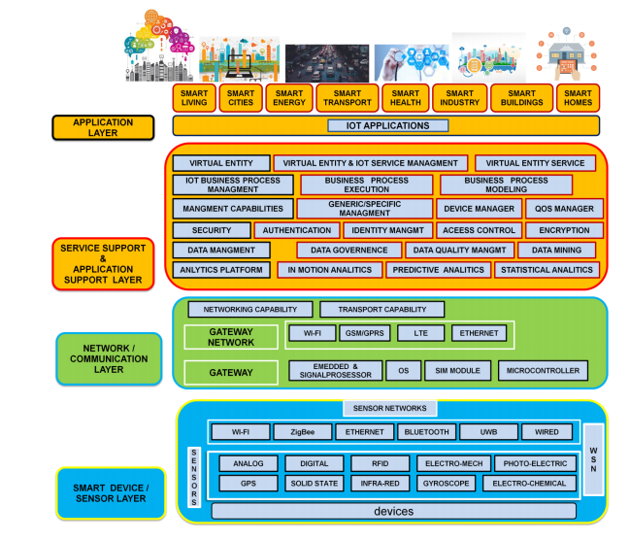
VI. FUTURE TECHNOLOGICAL DEVELOPMENTS FOR IOT.

Fig 5.9.3: IOT Layered Architecture
Source: https://encryptedtbn0.gstatic.com/images?q=tbn:ANd9GcQ7uJg5zSSPWvvHZcqGqSmlo0sDu_3ZKHrHRw&s
The development of enabling technologies such as semiconductor electronics, communications, sensors, smart phones, embedded systems, cloud networking, network virtualization and software will be essential to allow physical devices to operate in changing environments & to be connected all the time everywhere.

CHAPTER 6
RESULT

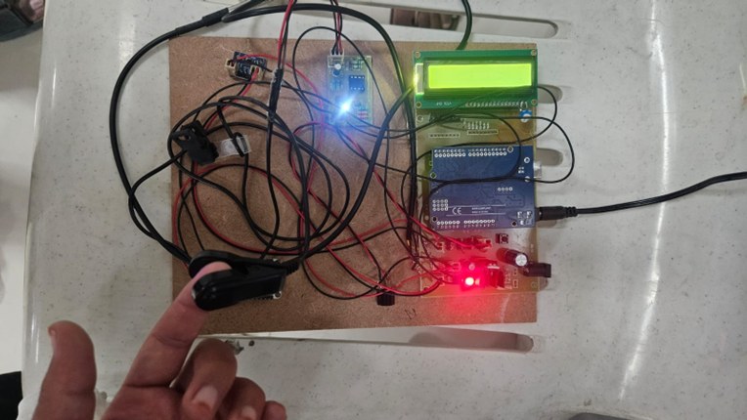

In this working model, the system successfully monitors important health parameters such as heart rate, body temperature, and movement using different sensors. The values are continuously displayed on the LCD screen, allowing the user to easily observe their current health condition in real time.
The Arduino Uno processes the data collected from the sensors and ensures accurate readings, while the NodeMCU enables wireless communication for remote monitoring. The system works efficiently by updating the data without delay, providing continuous observation of the patient’s condition.
When any parameter exceeds the normal threshold values, the system immediately activates the buzzer to alert the user and caregivers. This alert mechanism ensures quick response during emergency situations and helps in preventing serious health complications.
The MEMS sensor effectively detects body movements and position changes, which helps in identifying unusual conditions such as sudden movements or discomfort. This adds an extra level of safety to the system.
The overall system operates reliably with proper coordination between all components such as sensors, microcontrollers, LCD, and buzzer. The device is compact, easy to use, and suitable for continuous monitoring in real-time applications.
Finally, the results show that the proposed system is effective in providing accurate monitoring, timely alerts, and improved safety for pregnant women. It reduces the need for frequent hospital visits and supports better healthcare management.
Moreover, the system is designed to be user-friendly and cost-effective, making it suitable for use even in rural and remote areas. The integration of IoT technology helps in maintaining a continuous record of health data, which can be useful for future medical analysis and diagnosis. The device can be further enhanced by adding more sensors such as blood pressure or oxygen level monitoring for improved accuracy. Overall, this smart alert system provides a reliable, efficient, and advanced solution for continuous health monitoring and emergency alerting.

CHAPTER 7
APPLICATIONS , ADVANTAGES & LIMITATIONS
7.1 APPLICATIONS
Maternal Health Monitoring:
This system is mainly used for monitoring the health condition of pregnant women by continuously tracking parameters like heart rate, temperature, and body movement. It helps in identifying abnormalities at an early stage.
Home-Based Healthcare:
The device can be used at home, allowing users to monitor their health without frequent hospital visits. It provides comfort and convenience for continuous observation.
Hospital and Clinical Use:
In hospitals and maternity centers, the system can be used to monitor multiple patients efficiently and support doctors in providing better care.
Rural Healthcare Support:
The system is useful in rural and remote areas where medical facilities are limited. It helps in providing basic monitoring and alerting caregivers during emergencies.
Monitoring Elderly and Disabled Persons:
This device can also be used for elderly people and differently-abled individuals who need continuous health supervision.
Remote Monitoring Applications:
With the help of IoT, the system allows doctors and caregivers to monitor patient data from remote locations, ensuring timely medical support.

7.2 ADVANTAGES
Continuous Health Monitoring:
The system provides continuous monitoring of vital parameters such as heart rate, temperature, and movement, ensuring better observation of the patient’s condition.
Early Detection of Abnormalities:
It helps in identifying abnormal conditions at an early stage, allowing timely medical intervention and reducing health risks.
Real-Time Alerts:
The device generates immediate alerts using a buzzer when any parameter exceeds normal limits, ensuring quick response during emergencies.
Remote Monitoring:
With the help of NodeMCU and IoT, the system allows doctors and caregivers to monitor patient data from any location.
Reduced Hospital Visits:
The system minimizes the need for frequent hospital visits by enabling home-based monitoring, saving time and effort.
User-Friendly Design:
The device is simple to use and does not require technical knowledge, making it suitable for all users.
Cost-Effective Solution:
The system is designed using affordable components, making it accessible for a wide range of users.
Compact and Portable:
The device is lightweight and easy to carry, allowing continuous monitoring in different environments.
7.3 LIMITATIONS
Limited Sensor Accuracy:
The accuracy of the system depends on the sensors used, and small errors in sensor readings may affect the overall results.
Dependency on Internet Connection:
The system requires a stable internet connection for IoT-based remote monitoring. Without connectivity, remote access to data is not possible.
Power Supply Requirement:
Continuous operation of the system depends on a stable power supply. Power interruptions may affect monitoring.
Limited Parameters Monitored:
The system monitors only selected parameters like heart rate, temperature, and movement, and does not include all medical parameters.
Initial Setup Complexity:
Setting up the system and connecting all components may require basic technical knowledge.
Maintenance Requirement:
Regular checking and maintenance of sensors and components are needed to ensure accurate performance.
Data Security Concerns:
Since the system uses wireless communication, there may be risks related to data privacy and security.
CHAPTER 8
CONCLUSION AND FUTURE SCOPE
8.1 CONCLUSION
The Smart Alert Device for Pregnant Ladies is an effective solution for continuous health monitoring and early detection of complications during pregnancy. The system successfully integrates sensors, microcontrollers, and IoT technology to monitor important parameters such as heart rate, temperature, and body movement in real time.
The device provides accurate monitoring and immediate alert generation using a buzzer, ensuring quick response during abnormal conditions. The use of Arduino and NodeMCU enables efficient data processing and wireless communication, making the system reliable and easy to use.
This project reduces the need for frequent hospital visits by allowing home-based monitoring, which is especially useful for pregnant women in rural and remote areas. It also supports remote monitoring, enabling doctors and caregivers to track the patient’s health condition from anywhere.
Overall, the system is cost-effective, user-friendly, and suitable for real-time applications. It improves maternal safety, provides timely alerts, and enhances the quality of healthcare services. Thus, the Smart Alert Device plays an important role in ensuring better care and reducing risks during pregnancy.
Furthermore, the proposed system demonstrates how modern technology can be effectively used to improve healthcare services and ensure patient safety. The integration of embedded systems and IoT provides a strong foundation for developing smart and reliable monitoring devices. With further enhancements and additional features, this system can be expanded to support more advanced medical applications. Overall, the project highlights the importance of continuous monitoring and smart alert mechanisms in providing better healthcare solutions and improving the quality of life for patients.
8.2 FUTURE SCOPE
The proposed system can be further improved by adding more advanced sensors to monitor additional health parameters such as blood pressure, oxygen levels, and fetal heartbeat. This will provide a more complete health monitoring solution for pregnant women.
The system can be enhanced by developing a mobile application that allows users and doctors to easily view real-time data, receive alerts, and track health history in a more convenient way. This will improve user interaction and accessibility.
Integration of GPS technology can be added to track the location of the patient during emergency situations, helping in providing faster medical assistance.
The device can also be upgraded with advanced data analysis techniques such as artificial intelligence and machine learning to predict possible health risks based on previous data patterns.
Wireless communication can be further improved to provide faster and more secure data transmission, ensuring better reliability and data safety.
In addition, the system can be made more compact and wearable, increasing comfort for users and making it suitable for continuous use throughout the day.
Overall, the future scope of this project lies in enhancing its features, improving accuracy, and expanding its applications to provide a smarter and more efficient healthcare monitoring system.
Further improvements can focus on increasing the accuracy and reliability of the system by using high-quality sensors and better calibration techniques. The system can also be connected with hospital databases to maintain patient records automatically, making it easier for doctors to access medical history. With continuous advancements in technology, this device can be developed into a fully automated smart healthcare system that provides more efficient and personalized monitoring solutions.

REFERENCES
[1] S. Kumar, Y. Gupta, and V. Magoy, “Health-monitoring of pregnant women: Design requirements and proposed reference architecture,” in 16th IEEE Annual Consumer Communications & Networking Conference (CCNC), Las Vegas, NV, USA, 2019.
[2] World Health Organization, Maternal health: Improving maternal health outcomes, Geneva, Switzerland, 2020.
[3] UNICEF, Maternal health in rural and remote areas, New York, USA, 2019.
[4] International Telecommunication Union, IoT applications in healthcare: Opportunities and challenges, Geneva, Switzerland, 2018.
[5] Espressif Systems, ESP8266 Technical Reference Manual, Shanghai, China, 2021.
[6] M. M. Hossain, M. S. Rahman, and M. R. Islam, “Internet of Things in Pregnancy Care Monitoring,” International Journal of Advanced Computer Science and Applications, vol. 14, no. 2, pp. 210–216, 2023.
[7] S. K. Sharma and R. Gupta, “Smart Healthcare Monitoring System for Pregnant Women Using IoT,” International Journal of Engineering Research & Technology (IJERT), vol. 9, no. 5, pp. 345–349, 2020.
[8] S. Ansari, A. Khan, and P. Singh, “IoT-Based Health Monitoring System for Pregnant Women,” International Journal of Engineering and Advanced Technology (IJEAT), vol. 9, no. 4, pp. 1215–1219, 2020.
[9] R. Kumar and P. Malathi, “Design and Implementation of Smart Health Monitoring System Using Microcontroller,” International Journal of Innovative Technology and Exploring Engineering (IJITEE), vol. 8, no. 7, pp. 150–155, 2019.
[10] R. Ettiyan, S. Kumar, and K. Rajasekaran, “IoT-Based Intelligent Healthcare Monitoring System,” Procedia Computer Science, vol. 218, pp. 1450–1457, 2023.
[11] A. Verma and N. Jain, “Real-Time Health Monitoring and Alert System Using IoT,” International Journal of Scientific Research in Computer Science, vol. 11, no. 3, pp. 98–103, 2022.
[12] KSCST, “IoT-Based Pregnant Women Caretaking System,” Karnataka State Council for Science and Technology Project Report, 2023.
[13] M. J. C. Samonte et al., “Development of IoT-Based Pregnancy Monitoring System,” ACM Digital Library, 2023.
[14] P. Singh and R. Kaur, “Smart Alert System for Healthcare Monitoring Using IoT,” International Journal of Advanced Research in Science and Technology, vol. 10, no. 6, pp. 55–60, 2021.
[15] P. Singh and R. Kaur, “Smart Alert System for Healthcare Monitoring Using IoT,” International Journal of Advanced Research in Science and Technology, vol. 10, no. 6, pp. 55–60, 2021.
[16] S. Kumar and A. Singh, “Design of IoT-Based Health Monitoring System Using Arduino,” International Journal of Engineering Research & Technology, 2020.
[17] R. Sharma and P. Verma, “NodeMCU Based Smart Health Monitoring System,” International Journal of Innovative Research in Technology, 2021.
[18] A. Khan et al., “Sensor-Based Health Monitoring System for Pregnant Women,” International Journal of Advanced Research in Computer Science, 2020.
[19] M. Gupta and S. Jain, “MEMS Sensor Applications in Healthcare Monitoring,” International Journal of Scientific Research in Electronics, 2019.
[20] P. Reddy and K. Kumar, “Real-Time Health Monitoring Using IoT,” International Journal of Advanced Technology, 2022.
[21] V. Patel and R. Shah, “Design and Implementation of Smart Alert Systems in Healthcare,” International Journal of Engineering Science, 2021.
[22] K. Mehta and S. Patel, “Real-Time IoT-Based Health Monitoring System,” International Journal of Computer Applications, 2021.
[23] D. Roy and A. Das, “Smart Alert Mechanism for Healthcare Using Embedded Systems,” International Journal of Electronics and Communication, 2020.
[24] N. Verma and R. Singh, “Low Power IoT Devices for Healthcare Applications,” International Journal of Advanced Engineering Research, 2022.
[25] S. Rao and P. Nair, “Role of Smart Technologies in Maternal Healthcare,” International Journal of Healthcare Technology, 2023.
[26] A. Kumar and S. Gupta, “IoT Applications in Healthcare Monitoring Systems,” International Journal of Engineering Research, 2021.
[27] R. Singh and P. Sharma, “Limitations of Traditional Healthcare Monitoring Systems,” International Journal of Medical Informatics, 2020.
[28] M. Verma and K. Joshi, “Design of Smart Health Monitoring Devices Using IoT,” International Journal of Advanced Technology, 2022.
[29] S. Patel and R. Mehta, “Sensor Technologies in Healthcare Monitoring Systems,” International Journal of Electronics and Communication, 2021.
[30] N. Reddy and V. Kumar, “Software Implementation of IoT-Based Health Systems,” International Journal of Computer Science Engineering, 2022.
[31] P. Shah and A. Jain, “Performance Analysis of Smart Health Monitoring Devices,” International Journal of Scientific Research, 2023.
[32] D. Rao and S. Nair, “Future Scope of IoT in Healthcare Applications,” International Journal of Healthcare Technology, 2023.
[32] D. Rao and S. Nair, “Future Scope of IoT in Healthcare Applications,” International Journal of Healthcare Technology, 2023.
[33] R. Sharma and P. Gupta, “Traditional Healthcare Monitoring Systems for Pregnant Women,” International Journal of Medical Science, 2019.
[34] S. Verma and A. Singh, “Challenges in Rural Healthcare Monitoring,” International Journal of Healthcare Research, 2020.
[35] M. Khan and R. Ali, “Wearable Sensor-Based Health Monitoring Systems,” International Journal of Electronics and Communication, 2021.
[36] P. Mehta and S. Jain, “Limitations of Conventional Health Monitoring Devices,” International Journal of Biomedical Engineering, 2020.
[37] N. Patel and K. Shah, “Manual vs Automated Healthcare Monitoring Systems,” International Journal of Advanced Technology, 2022.
[38] D. Kumar and R. Reddy, “Need for IoT-Based Smart Healthcare Systems,” International Journal of Computer Science and Engineering, 2023.
[33] R. Sharma and P. Gupta, “Traditional Healthcare Monitoring Systems for Pregnant Women,” International Journal of Medical Science, 2019.
[34] S. Verma and A. Singh, “Challenges in Rural Healthcare Monitoring,” International Journal of Healthcare Research, 2020.
[35] M. Khan and R. Ali, “Wearable Sensor-Based Health Monitoring Systems,” International Journal of Electronics and Communication, 2021.
[36] P. Mehta and S. Jain, “Limitations of Conventional Health Monitoring Devices,” International Journal of Biomedical Engineering, 2020.
[37] N. Patel and K. Shah, “Manual vs Automated Healthcare Monitoring Systems,” International Journal of Advanced Technology, 2022.
[38] D. Kumar and R. Reddy, “Need for IoT-Based Smart Healthcare Systems,” International Journal of Computer Science and Engineering, 2023.
[39] S. Verma and A. Singh, “Challenges in Rural Healthcare Monitoring,” International Journal of Healthcare Research, 2020.
[40] M. Khan and R. Ali, “Wearable Sensor-Based Health Monitoring Systems,” International Journal of Electronics and Communication, 2021.
[41] P. Mehta and S. Jain, “Limitations of Conventional Health Monitoring Devices,” International Journal of Biomedical Engineering, 2020.
[42] N. Patel and K. Shah, “Manual vs Automated Healthcare Monitoring Systems,” International Journal of Advanced Technology, 2022.
[43] D. Kumar and R. Reddy, “Need for IoT-Based Smart Healthcare Systems,” International Journal of Computer Science and Engineering, 2023.
[44] A. Kumar and S. Singh, “IoT-Based Smart Health Monitoring System,” International Journal of Engineering Research, 2022.
[45] R. Sharma and P. Verma, “Sensor-Based Health Monitoring Using Arduino,” International Journal of Electronics Engineering, 2021.
[46] M. Patel and K. Shah, “Microcontroller-Based Health Monitoring System Design,” International Journal of Embedded Systems, 2020.
[47] S. Reddy and V. Kumar, “NodeMCU-Based IoT Communication System,” International Journal of Computer Science, 2022.
[48] P. Mehta and A. Jain, “Smart Alert Systems in Healthcare Using IoT,” International Journal of Advanced Technology, 2021.
[49] N. Gupta and R. Singh, “Low-Cost Healthcare Monitoring Devices,” International Journal of Healthcare Engineering, 2023.
[50] D. Roy and S. Das, “Cloud-Based Health Monitoring Systems,” International Journal of Information Technology, 2022.
[51] K. Rao and P. Nair, “Real-Time IoT Healthcare Applications,” International Journal of Smart Technology, 2023.
[52] R. Kamal, Embedded Systems: Architecture, Programming and Design, McGraw Hill, 2017.
[53] S. Heath, Embedded Systems Design, Newnes Publications, 2018.
[54] K. V. Shibu, Introduction to Embedded Systems, Tata McGraw Hill, 2019.

